STUDENTS’ MATHEMATICAL THINKING SOLVING
MATH STORY PROBLEMS

Meira Indria Pratiwi, , Susiswo , Santi Irawati
State University of Malang , Malang
*Corresponding Authors: susiswo.fmipa@um.ac.id

Submitted : 11-07-2025 | Revised : DD-MM-YY | Accepted : DD-MM-YY | Published:DD-MM-YY

ABSTRACT

Mathematics story problems are important to learn because they relate to contextual life. In the preliminary study, many MTs Qita Malang students made mistakes. One way to find out students' mistakes is to explore how they think mathematically. Therefore, the researcher conducted a study that aimed to describe how students think mathematically in solving mathematical story problems. The instruments used were test sheets and interview guidelines. This research is a qualitative-descriptive research that was attended by 15 grade IX students of MTs Qita Malang. Three research subjects were selected based on their ability level (high, medium, low). The results showed that students were highly capable through all aspects in the entry and attack phases, but missed the check and extend aspects in the review phase. Moderately capable students go through all aspects in the entry phase and skip the why aspect in the attack phase and only succeed through the reflect aspect in the review phase. Low ability students go through the entry phase of the know and want aspect, but skip the maybe and why aspect in the attack phase, and only through the reflect aspect in the review phase.

Keywords: Mason; Mathematical thinking; Math story problems

INTRODUCTION
Mathematical thinking is the ability to use logic in making mathematical arguments, developing strategies, understanding mathematical concepts, and conveying ideas clearly (Firmansyah et al., 2024). This ability helps students in compiling problem solving steps coherently and reasonably so that the solution obtained can be accounted for (Badi’ah et al., 2024). Mathematical thinking is also called a series of mathematical and mental actions(Scheiner, 2023). Therefore, mathematical thinking is an important ability that students must have in learning mathematics. In learning mathematics, mathematical thinking skills are not only needed to solve calculation problems, but also story problems that connect mathematics to everyday life.
Mathematics story problems have an important role in developing students' logical and analytical thinking skills (Sanidah & Sumartini, 2022). Powell, et al (2017) state that story problems are a combination of sentences and numbers that require perceptual abilities from students to understand them. This type of problem requires students to read and understand information, connect it with mathematical concepts, and then develop the appropriate model or equation before solving the problem (Khasanah, 2015). Thus, story problems can help students relate math to real situations. However, in reality, not a few students make mistakes in solving math story problems even though the problems are related to everyday contexts (Irianti et al., 2016). This also happens to students of MTs Qita Malang, which based on the results of preliminary observations, there are still many who make mistakes in working on math story problems.
The mathematical thinking process of students in solving story problems can be explained through the theory of Mason et al. (2010) which divides the process into three phases, namely entry, attack, and review. In the entry phase, students are expected to understand the information in the problem (know aspect), determine what is asked (want aspect), and make a mathematical representation of the problem (introduce aspect) (Natalia et al., 2016). In the attack phase, students try to find solutions through initial conjectures (try aspect), assess the conjecture (maybe aspect), and provide reasons for the steps (why aspect) (Wardhani et al., 2016). The last phase is review, where students re-examine the results of their work (check aspect), reflect on the process that has been done (reflect aspect), and consider alternative strategies (extend aspect) (Dewi et al., 2019) . Thus, this process shows that the success of solving story problems does not only depend on the mastery of procedures, but also on the ability to understand, plan, check, and develop strategies as a whole.
Various previous studies have shown that student errors in solving story problems are often not caused by ignorance of formulas or steps, but because of errors in mathematical thinking. These errors can be in the form of misunderstanding the problem, writing the wrong mathematical model, incorrect working procedures, and lack of reflection on the answers obtained (Sanidah & Sumartini, 2022). Prayitno et al. (2018) emphasize that errors that are not identified and corrected can lead to misunderstandings in subsequent mathematical concepts. Therefore, it is important to deeply explore students' mathematical thinking process when solving story problems, so that teachers can find out where the mistakes are and how to assist students to correct them.
Most of the research that has previously been conducted on mathematical thinking and errors in solving story problems, generally only focuses on identifying the types of errors made by students without digging deeper into the mathematical thinking behind these errors. Different from previous studies, this study aims to describe students' mathematical thinking in solving math story problems so that the location of errors in each phase of thinking can be known. By understanding the location of errors in mathematical thinking, it is hoped that this research can help optimize students' mathematical thinking skills and help reduce errors when solving mathematical story problems.

RESEARCH METHODS
This research aims to produce descriptive data in the form of descriptions in the form of words regarding the mathematical thinking of the research subjects, as well as oral statements from the subjects studied conducted through interviews (Moleong, 2017). This study involved 15 students of class IX MTs Qita Malang in even semester as research subjects. From the test results given, three students were selected to represent three categories of mathematical thinking ability based on the Minimum Completeness Criteria (KKM), namely: high category (S1) with a score > 80, medium category (S2) with a score of 50-80, and low category (S3) with a score < 50. The three subjects were chosen to represent the diversity of students' mathematical thinking ability levels in solving story problems. The data collection instruments used in this study were tests and interview guidelines. The test consisted of two description questions, while the interview was conducted in depth with the three subjects to confirm and further explore the mathematical thinking process that had not been illustrated from the test results.

RESULTS AND DISCUSSION
Mathematical Thinking of Medium Ability Students

When solving story problems, students with high abilities go through three phases of mathematical thinking, namely entry, attack, and review. The S1 work process in the entry phase can be seen in the following figure 1.
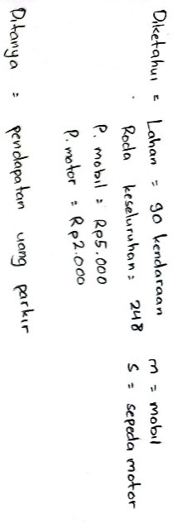
Figure 1. S1 test results in the entry phase

The following are the results of the interview in the entry phase.
P | : | What is the information contained in the question?
S1 | : | There is a parking lot that provides land for 90 vehicles, then the total wheel is 248, the cost of parking the Rp. 5000 car and the parking of the Rp. 2000 motorcycle
P | : | Then what do you want in the question?
S1 | : | Determining the income of the parking fee
P | : | Do you make representations of problems, such as making symbols?
S1 | : | Yes, for example, I think a car with a variable $m$ and a motorcycle with a variable $s$

In the entry phase, S1 went through the know, want, and introduce aspects well. S1 through the aspect of know which can be seen from his ability to understand the problem carefully. S1 is able to sort the information contained in the problem given. This shows that S1 through the want aspect. In addition, S1 also goes through the introduce aspect because S1 can memorize the elements contained in the information in the problem, namely memorizing cars with and motorbikes with . This is in accordance with research which states that high ability students can generally go through all three aspects in the entry phase very well (Widyastuti et al., 2017)
In the attack phase, S1 went through the aspects of try, maybe, and why. S1 through the try aspect because the answer results show that S1 makes an initial guess of the solution, namely by modeling the mathematical equation as in Figure 2 below.

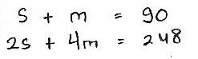
Figure 2. S1 test results in the attack phase of the try aspect

The alleged solution made has been tried, whether the conjecture is able to solve the problem or not. S1 uses a combined method, namely elimination and continued with elimination. This shows that S1 goes through the maybe aspect. The completion step can be seen in figure 3 below.
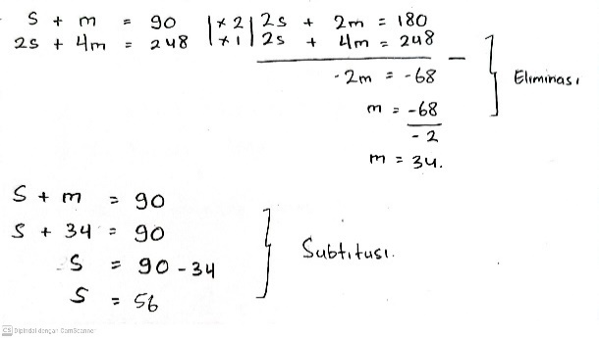
Figure 3. S1 test results in the attack phase of the maybe aspect

After getting the value of the two variables, S1 multiplies the value by the cost of parking the vehicle. This is reflected in Figure 4.

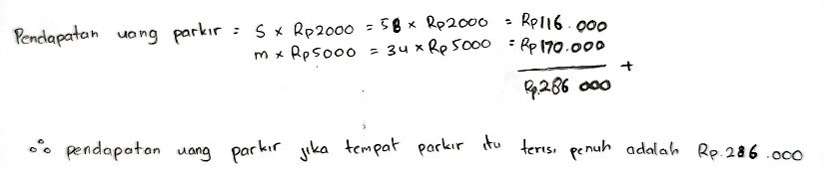
Figure 4. S1 test results in the attack phase of the maybe aspect

In addition, S1 is also able to convince others in writing and verbally that the solution steps taken are correct. Therefore, S1 can be said through the why aspect. S1 solves the problem systematically. A similar opinion by Wardhani (2016) states that high ability students try to solve the problems given in a detailed and sequential manner. The following are the results of the interview in the attack phase.

P | : | What is the first step you took to solve this problem?
S1 | : | First, I made a system of linear equations.  Namely $s+m=90$ and $2s+4m=248$
 |  | S It's a motorcycle and m it's a car. It is known that the total number of vehicles is 90, so motorcycles and cars will be increased to 90
If the second equation is true, there are 2 motorcycle wheels and 4 car wheels.
So $2s+4m=248$ . The 248 was obtained from the wheel.
P | : | Then what's the next step?
S1 | : | Next I eliminated equations one and two, then got the value of $m$ 34. Then I continued by substituting the value of m to the first equation and got the value of $s$56. After that, I multiplied the values of $s$ and $m$by the parking price. Then I totaled and got a result of 286.000

In the review phase, S1 only goes through the reflect aspect. This is supported by Delima's opinion (2017) that high ability students, at least pass one stage in the review phase. S1 did not go through the check aspect because S1 did not re-examine the solution that had been made, whether it was in accordance with the question or not. S1 went through the reflect aspect because the subject was able to reflect on the conjectures in the solution and which parts were difficult in the given problem. The extend aspect is not passed by S3, because the subject does not get another way of solving. Although not completing all aspects of the review phase, S1 almost produced the right answer. This can be seen from the following interview excerpt.

P | : | After working on the problem, did you check your completion steps?
S1 | : | No
P | : | Are there any difficultproblems whensolving each of these problems?
S1 | : | No
P | : | Do you have any other solutions to solve the problem?
S1 | : | Emm, as far as I know the SPLDV settlement method is just elimination and substitution, and I've used them all. So there seems to be no other way.

Mathematical Thinking of Medium Ability Students

S2 can find what information is known and needed to solve the problem well in the initial step of solving which indicates that S2 understands the problem given. Moderate ability students show a fairly good initial ability to read and analyze information, so they are able to identify known data and relevant information (Dewi et al., 2019). Figure 5 below shows S2's work in the entry phase.

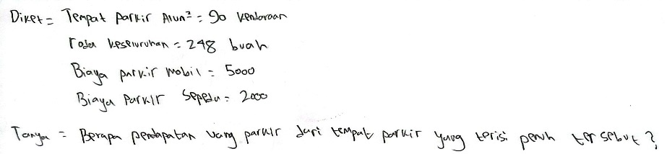
Figure 5. S2 test results in the entry phase

In the entry phase, S2 went through the aspects of know, want, and introduce. S2 through the know aspect which can be shown from S2's understanding of the problem. S2 was able to understand the problem well. S2 through the want aspect which is shown through his ability to sort the information contained in the problem given. In addition, S2 also goes through the introduce aspect because S2 is able to memorize the elements contained in the problem, namely memorizing cars with and motorbikes with . The following are the results of the interview at the entry phase.

P | : | What information is in the question?
S2 | : | The parking lot accommodates 90 vehicles, the total number of wheels is 24, car Rp5.000 and motorcycle Rp2.000 parking fees
P | : | What does the vehicle consist of?
S2 | : | Cars and motorcycles.
P | : | What is asked in the question?
S2 | : | The amount of money earned from parking fees.
P | : | Do you create a model or symbol from a question?
S2 | : | Yes, we use variables x and y . Which x is for bicycles and y for cars

In the attack phase, S2 went through the try and maybe aspects. The answer results show that S2 made an initial guess of the solution, namely by making a mathematical equation model, which means S2 went through the try aspect. This is shown in Figure 6.

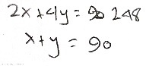
Figure 6. S2 test results in the attack phase of the try aspect

S2 went through the maybe aspect by trying the alleged solution that had been made even though the process was not complete. A similar opinion expressed by Suryaningrum (2020) menyatakan bahwa siswa berkemampuan sedang tidak mau memaksimalkan states that moderate ability students do not want to maximize their efforts. The results of S2's work can be seen in Figure 7 below.

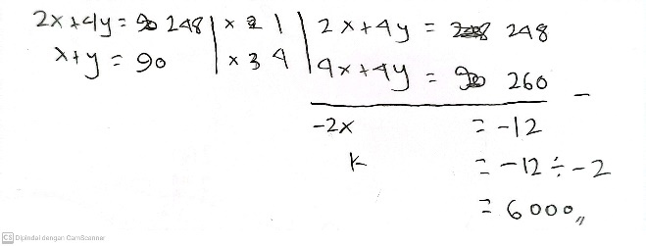
Figure 7. S2 test results in the attack phase of the maybe aspect

The following are the results of the interview in the attack phase.

P | : | What is the first step you took to solve this problem?
S2 | : | I made equation, $2x+4y=248$ and $x+y=90$
 |  | Then I subtract the first and second equations. Then I got a score $x$ of 6000.
P | : | Is the completion step completed?
S2 | : | Not yet, I still forget to remember the continuation
P | : | Are you sure your answer is correct?
S2 | : | (Smiles) Hehehe not us. The problem is that I have not finished it, but I am still confused about continuing. So, I just did that.

In the review phase, S2 went through the reflect aspect only. The check aspect was not passed by S2 because the subject did not re-examine the solution that had been made, whether it had answered the question or not. This is similar to the opinion of Sanjaya et al (2018) regarding moderate ability students not rechecking the process and results obtained, resulting in calculation errors. S2 through the reflect aspect because the subject is able to reflect on which part is difficult in the problem given. S3 cannot have another way of solving. This shows that S2 does not go through the extend aspect which is reflected in the following interview excerpt.

P | : | After working on the problem, did you check your completion steps?
S2 | : | No
P | : | Is there anything difficult when solving each of these problems?
S2 | : | That's, I had a hard time continuing the way because I forgot. Must read the book again.
P | : | Do you have any other solutions to solve the problem?
S2 | : | In the past, it seemed that there were several ways to solve it, besides the one I used. But I still don't remember us

Mathematical Thinking of Low Ability Students

S3 is less able to solve the problems given when solving story problems. S3 is less able to explain the answer and looks confused about how to explain each part of the answer that has been made. This is in line with previous research which shows that low ability students are less able to understand the meaning of the problem (Rahmawati, 2019). The following is an excerpt of S3's interview with the researcher in the entry phase.

P | : | What information do you get from this question?
S3 | : | There are 90 vehicles in the parking lot. Then the total number of wheels is 248. The same cost of parking the car and motorcycle Rp5.000 and Rp2.000
P | : | What does the vehicle consist of?
S3 | : | There are cars and motorcycles.
P | : | What is asked in the question?
S3 | : | Revenue from the parking lot
P | : | Do you create a model or symbol from a question?
S3 | : | No

In the entry phase, S3 through the aspects of know, want, and introduce. S3 can express the information known and asked about the problem. This indicates that S3 through aspects know. In addition, S3 is able to sort the right information in the problem so that it can be known S3 through the want aspect. S3 cannot formalize the elements contained in the problem. Therefore, it can be said that S3 does not go through the introduce aspect.

In the attack phase, S3 only goes through the try aspect. The results of S3's work can be seen in Figure 8.
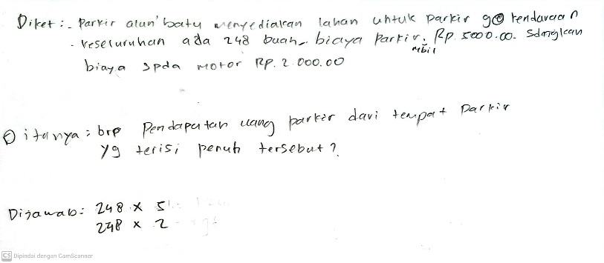
Figure 8. S3 test results in the entry and attack phases

The following is an excerpt of the interview at the attack phase.

P | : | What is the first step you took to solve this problem?
S3 | : | That's us I multiply 248 by 5, then 248 multiplied by 2
P | : | Where did these numbers come from?
S3 | : | 248 is from the total number of wheels, if 5 from where.  Oh 5 from car parking, if 2 from motorbike parking
P | : | Isn't it mentioned that if car parking Rp. 5000 is a bicycle parking while a bicycle Rp. 2000 is parking, how can it be 5 and 2?
S3 | : | Hehe, I don't know about you either. I was confused about how to do it. So I just use the numbers in question.
P | : | So what's the next step?
S3 | : | I don't know. Instead of empty, so yesterday I did that hehe
P | : | Do you remember what material this is?
S3 | : | I don't remember us, it seems like there are linearities
P | : | Are you sure your answer is correct?
S3 | : | Definitely not, because the way is impossible just like that hehe

The test results show that the subject makes an initial guess of completion, namely by using the numbers in the problem. This is in line with the opinion of (Agustini & Pujiastuti, 2021) which says that the subject only works until making the mathematical model, and even then it is still not correct. S3 does not know whether the conjecture that has been made is able to solve the problem or not. Even so, S3 is said to go through the try aspect. S3 did not try the alleged solution that had been made, so S3 did not go through the maybe aspect. S3 cannot make others convinced in writing or verbally that the solution steps obtained are correct. So it is known that S3 does not go through the why aspect. S3 did not do the attack phase well.

In the review phase, S3 went through the reflect aspect only. The following is an excerpt of the interview in the review phase.

P | : | After working on the problem, did you check your completion steps?
S3 | : | Not
P | : | Is there anything difficultwhensolving this problem?
S3 | : | Yes, it's all difficult. The problem is that I don't understand how to solve it
P | : | Do you have any other solutions to solve the problem?
S3 | : | No, I don’t have

Based on the quote, it can be seen that the check aspect is not passed because S3 does not re-examine the answers that have been made, whether they are in accordance with the question or not. S3 through the reflect aspect because the subject can reflect on which parts are difficult in the given problem. The extend aspect is also not passed by S3 because it does not find another way of solving. A similar opinion is also expressed by (Nurhayati dkk., 2022) which says that low ability students still need guidance in evaluating the process of solving and calculating math story problems.

CONCLUSION
Based on the results of the research and discussion that has been carried out, it can be concluded that in solving math story problems, high ability students are able to carry out all three phases of mathematical thinking. High ability students do the entry phase well, it can be seen from their success in understanding the problem information, sorting data, and compiling the right mathematical model. In the attack phase, students also show the ability to formulate conjectures, try the solution steps, and explain the reasons for the strategies used systematically. However, in the review phase, students were only able to reflect on the process without re-examining the results of their work or considering alternative solutions, so there were few errors in the final result.
Moderate ability students perform the entry phase quite well, indicated by their ability to understand the problem information, sort data, and make initial mathematical models even though most of them only follow the problem pattern. In the attack phase, students made conjectures and tried the solution steps, but could not continue the solution until the end and could not explain the reasons for the steps taken. In the review phase, students reflected on the parts they found difficult without re-examining their work or looking for other solution methods.
Low ability students performed a small part of the mathematical thinking phase. In the entry phase, students mention the known and questionable information, but are unable to compile the right model so that the introduce aspect is not done. In the attack phase, students make conjectures by trying to connect the numbers from the problem without a good understanding. In addition, students do not try the conjecture and cannot explain the steps, so the aspects of maybe and why are not done. In the review phase, students reflect on their difficulties in solving the problem, without rechecking the results and looking for other ways of solving.

REFERENCES
Agustini, D., & Pujiastuti, H. (2021). Analisis Kesulitan Siswa Berdasarkan Kemampuan Pemahaman Matematis dalam Menyelesaikan Soal Cerita Pada Materi FPB dan KPK. Fraktal: Jurnal Matematika Dan Pendidikan Matematika, 2(2), 29–42. https://doi.org/10.35508/fractal.v2i2.5638
Badi’ah, S., As’ari, A. R., & Hidayah, I. N. (2024). Interpreting Skills to The Student’s Mathematical Problem-Solving Process. Prisma, 13(1), 123. https://doi.org/10.35194/jp.v13i1.3941
Delima, N. (2017). a Relationship Between Problem Solving Ability and Students’ Mathematical Thinking. Infinity Journal, 6(1), 21. https://doi.org/10.22460/infinity.v6i1.231
Dewi, I. R. S., Chandra, T. D., & Susanto, H. (2019). Proses Berpikir Mahasiswa Field Dependent Berdasarkan Kerangka Berpikir Mason. Jurnal Pendidikan: Teori, Penelitian, Dan Pengembangan, 4(7), 960. https://doi.org/10.17977/jptpp.v4i7.12643
Firmansyah, E., Baluta, I. B., & Elfaituri, K. (2024). The Correlation between Students ’ Problem-Solving Abilities and Their Mathematical Thinking in High School Mathematics Education. 2(2), 132–140. https://doi.org/10.37251/ijome.v2i2.1343
Irianti, N. P., Subanji, S., & Chandra, T. D. (2016). Proses Berpikir Siswa Quitter dalam Menyelesaikan Masalah SPLDV Berdasarkan Langkah-langkah Polya. JMPM: Jurnal Matematika Dan Pendidikan Matematika.
Moleong, L. J. (2017). Metodologi Penelitian Kualitatif. In Bandung: PT Remaja Rosdakarya.
Natalia, K., Subanji, & Sulandra, I. M. (2016). MISKONSEPSI PADA PENYELESAIAN SOAL ALJABAR SISWA KELAS VIII BERDASARKAN PROSES BERPIKIR MASON. Jurnal Pendidikan.
Nurhayati, N., Subanji, S., & Rahardjo, S. (2022). Proses Pemecahan Masalah Sistem Persamaan Linear Dua Variabel Berdasarkan Tahapan Mason Ditinjau dari Tipe Adversity Quotient. Jurnal Cendekia : Jurnal Pendidikan Matematika, 6(1), 615–634. https://doi.org/10.31004/cendekia.v6i1.1239
Powell, S. R., Berry, K. A., Benz, S. A., Forsyth, S. R., & Martinez-Lincoln, A. (2017). Teaching Students to Understand and Solve Word Problems. Texas Mathematics Teacher, 63(2), 6–12.
Prayitno, A., Kaka, R., & Hamid, A. (2018). PEMBERIAN SCAFFOLDING BERDASARKAN KESALAHAN BERPIKIR SISWA DALAM MEMECAHKAN MASALAH MATEMATIKA. JURNAL REVIEW PEMBELAJARAN MATEMATIKA.
Rahmawati, A. (2019). Analisis Kesulitan Siswa dalam Menyelesaikan Soal Cerita Matematika Berbasis Pembelajaran Pemecahan Masalah Kelas V SD Negeri Gebangsari 03. Jurnal Pengembangan Pembelajaran Matematika, I(2), 30–3.
Sanidah, S., & Sumartini, T. S. (2022). Kesulitan siswa kelas viii dalam menyelesaikan soal cerita spldv dengan menggunakan langkah polya di desa cihikeu. Jurnal Inovasi Pembelajaran Matematika: PowerMathEdu, 1(1), 15–26. https://doi.org/10.31980/powermathedu.v1i1.1912
Sanjaya, A., Johar, R., Ikhsan, M., & Khairi, L. (2018). Students’ thinking process in solving mathematical problems based on the levels of mathematical ability. Journal of Physics: Conference Series, 1088, 1–7. https://doi.org/10.1088/1742-6596/1088/1/012116
Scheiner, T. (2023). Shifting the ways prospective teachers frame and notice student mathematical thinking: from deficits to strengths. Educational Studies in Mathematics, 114(1), 35–61. https://doi.org/10.1007/s10649-023-10235-y
Sumartini, T. S., & Safitri, L. (2022). Analisis Kesalahan Siswa SMP dalam Menyelesaikan Soal Cerita Sistem Persamaan Linear Dua Variabel Berdasarkan Prosedur Newman. Prisma, 11(2), 302. https://doi.org/10.35194/jp.v11i2.2193
Suryaningrum, C. W., Purwanto, Subanji, Susanto, H., Ningtyas, Y. D. W. K., & Irfan, M. (2020). Semiotic reasoning emerges in constructing properties of a rectangle: A study of adversity quotient. Journal on Mathematics Education, 11(1), 95–110. https://doi.org/10.22342/jme.11.1.9766.95-110
Wardhani, W. A., Subanji, & Dwiyana. (2016). PROSES BERPIKIR SISWA BERDASARKAN. 297–313.
Widyastuti, R., Usodo, B., & Riyadi. (2017). Proses Berpikir Siswa SMP Dalam Menyelesaikan Masalah Matematika Berdasarkan Langkah- Langkah Polya Ditinjau dari Adversity Quotient. Jurmal Pembelajaran Matematika, 1(3), 239–249.

