APPENDIX I (Creative Thinking Assessment Instrument)
- Rama is going to a traditional market and sees one of the traditional snacks called Jipang.
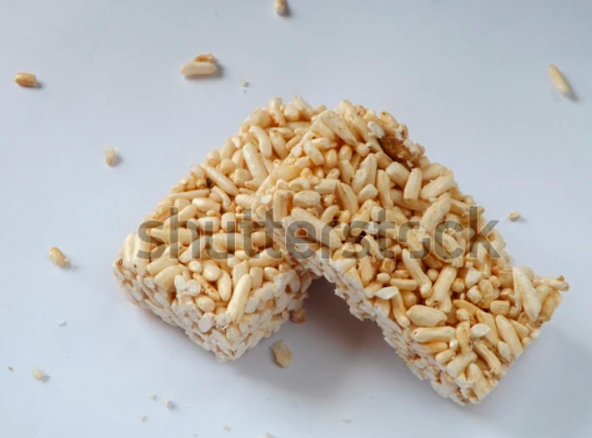
Rama wants to buy Jipang as a souvenir for his family. However, he wants the Jipang to be packaged in individual boxes (per piece) to look neat. Determine the number of possible nets that can be formed into a box containing Jipang. Provide at least 3 possibilities!
- Indonesia is one of the countries with a diversity of both traditional and modern foods. One example is the Kue Balok (Block Cake) from Bandung.
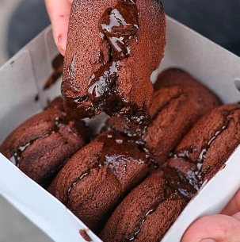
Given that the size of the Kue Balok is 6 cm in length, 3 cm in width, and 2 cm in height, determine the possible dimensions (length, width, and height) of the Kue Balok box if each box contains a maximum of 6 pieces. Provide at least 2 possibilities!
- Based on the box used for packaging the Kue Balok (Question no 2), determine how many possible carton surface areas are needed to form one box. Provide at least 2 possibilities!
- Joglo traditional house is one of the cultural heritages that is still preserved today. This building is typical of Java and is known for its supporting pillars called soko guru.
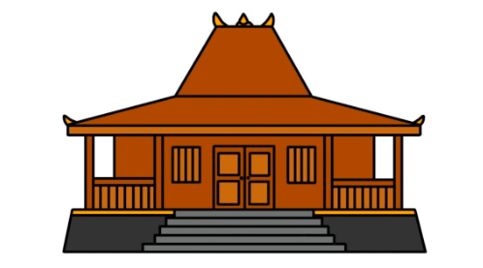
If Mr. Rahmat plans to build a Joglo house and use mahogany wood with a volume of 384 cm³, find the possible dimensions (length, width, and height) of the soko guru pillar. Provide at least 2 possibilities!
- Based on question number 4 related to the soko guru, determine how many possible surface areas the solid figure could have!
- The ancient Mayan pyramid is one of the world’s most iconic archaeological structures. One of its functions is as a place of worship located at the top of the pyramid. This place is commonly called a temple or altar, where religious leaders perform rituals and offerings, and it is shaped like a rectangular prism.
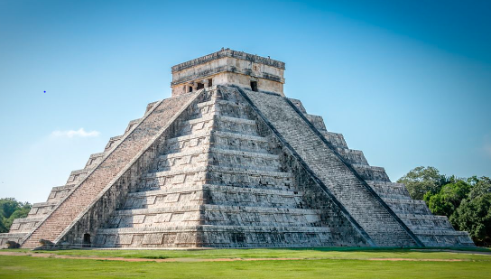
Given that the altar has a length of 9 m, width of 4 m, and height of 6 m, draw at least 2 other solid figures with flat faces that have the same volume as the altar and show their dimensions!
- Based on question no 6, if the volume of the altar is known to be 480 m³, find several possible dimensions (length, width, and height) of the altar!
- A die (dice) is one of the objects used in board games like snakes and ladders or other children's games. Each face of the die has a different number of dots. Determine several possible nets that can form a complete die along with its dots. Provide at least 2 possibilities!
- Brown Sugar Cube is one of the innovations in the food sector introduced by palm sugar artisans. Currently, the demand for Brown Sugar Cube is soaring because of its minimalist and practical shape.
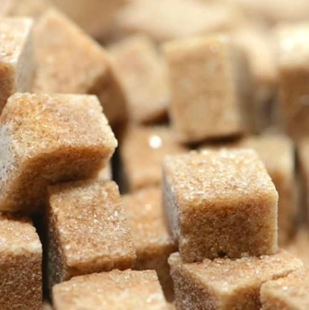
For its packaging, the seller uses a box made in the shape of a cube. If the box volume is 512 cm³, determine the possible number of Brown Sugar Cubes that can fit inside the box!
- Traditional cakes are increasingly popular due to their more modern packaging. One example is the cookie box. These cookies are popular among teenagers and adults because of their delicious taste and minimalist appearance..
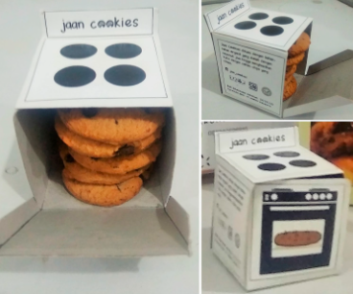
The cookies are usually flat and round with a diameter of 5 cm and a height of 0.5 cm. Determine the possible number of cookies that can fit in a box if the box is cube-shaped!

