Implementation of a Web-Based SPP Payment Recording Information System and SMS Gateway Using the Waterfall Method
Muhamad Zaqy ^{a,1} , Galih ^{b,2*} , Moch. Irwan Hermanto ^{c,3}
^{ab} Islan Nusantara University, Jl. Soekarno Hatta no.530, Bandung City 40286 West Java
¹ muhamadzaqy530@gmail.com*; ² galih@uninus.ac.id; mochirwanh@gmail.com

ARTICLE INFO |  | ABSTRACT (10pt)
Article history  Received  Revised  Accepted |  | The utilization of information and communication technology in the field of education has not been maximized, one of which is the management of tuition payment data at SMK Bhakti Putra, which still uses conventional methods and has not been computerized. Based on the above problems, this study aims to design and develop a web-based information system and use SMS Gateway that can help manage tuition payment data. The data collection method in this study is the observation method by directly observing the work processes carried out in the agency to obtain a clear picture of the object being studied. The results of this study are a web-based tuition payment information system and SMS Gateway developed using PHP, MySQL, and the Bootstrap Framework. The result is a new system that can maximize the work of the TU (Administration) section in presenting payment information, accuracy, and administrative services for tuition payments can be carried out effectively and efficiently.
Keywords
SPP Payment
SMS Gateway
Waterfall
Website

Introduction
Information systems are commonplace and inseparable from organizations, including educational institutions such as[1] . Technology and information are developing rapidly, such as the internet, computers, and telecommunications technology. This is due to the need to utilize technology and information to facilitate work in various fields, including education. The main focus is on SPP, which stands for Sumbangan Pembinaan Pendidikan (Education Development Contribution), which is funds donated for educational activities at an institution[2] . Educational institutions must be able to provide services related to education, such as academic information and the SPP payment information system[3] . In the world of education, information and communication technology can be utilized to manage SPP payments, which are currently still carried out manually using books for recording.
SMK Bhakti Putra is located in Bandung Regency, where tuition fees are paid by parents or guardians of students every month for school operations. The recording of tuition fee payments is still done using Microsoft Excel to compile payment data by financial officers. Then, each bill is issued by teachers who notify each student, which causes delays in information and payments.
This study proposes an information system in the form of a website-based tuition payment recording application to make it more effective and efficient in processing payment data from each student and also to make it easier for financial officers to report to the Foundation.

Method
This research method applies the case study research method, which is conducted by examining a program, event, or activity in greater depth and detail at the individual, group, institutional, or organizational level[4] . In order to gain a deeper understanding of the issues, it is necessary to explore one or more cases within a specified time frame and to collect primary data from various sources through interviews, observations, and other document collection methods.
2.1 Literature Study
Literature study is an effort made in the activity of collecting library data through the process of reading, taking notes, and then managing reading materials for research[5] . The literature study stage involves searching for theories that are relevant to the case studies found in the field. References can be found by reading journals, articles, and specific books, as well as utilizing the mass media as a broader source of information. The results of this literature study process can be obtained with references that are relevant to the problems formulated in this practicum.
2.2 Data Collection Techniques
To collect the main data, several techniques were applied, namely observation and interviews. In collecting data through observation of the research object at the school, the focus was on tuition payment activities under the auspices of the finance department in order to capture an overview of the existing system. Meanwhile, the interview technique involved direct communication with finance department staff. This activity was filled with questions directly related to the problems that occurred, so that the shortcomings and problems that could be answered and resolved by utilizing information technology could be explored.
2.3 Software Development Method
This method uses the waterfall development model. The Waterfall Model is a classic software development model that has structured stages and is commonly used in information technology[6] . These stages are analysis, design, implementation, testing, and maintenance.

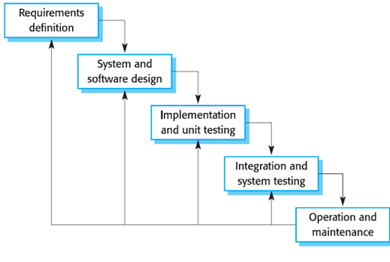
Fig.1 . Waterfall Model [7]

a. Requirements (needs analysis)
At this stage, an analysis of the requirements of the system to be implemented is carried out. Several efforts are made, such as data collection through interviews and literature studies. The system analyst will seek relevant information from users in running the system as well as other additional information to produce user requirement documents that will be used as guidelines or references for system analysis in translating general language into programming language in forming the SPP payment recording information system application.
b. Design
The design stage is the phase of designing the application that is carried out before coding implementation in order to provide an overall picture of what will be done during its development. To assist programmers in implementation, it is documented using the Unified Modeling Language (UML).
c. Implementation
After the system development design document is formed, the programmer then writes the program code, which is translated from the previous flow, architecture, and display design using the PHP programming language and MySQL for the database.
d. Testing
Testing is carried out after the application is formed at the implementation stage using the waterfall method. This testing is used to ensure that the application to be implemented meets the requirements specified in the previous stages. Testing of the program uses the Black Box Testing technique. The completed SPP payment information system must first undergo system testing to avoid errors in the system's functions when it is put into use.
e. Operation & Maintenance
In the final stage of the waterfall method, maintenance is carried out, one of the activities of which is to make corrections if there are errors or defects in the program during development by the quality assurance department using a test case scheme in the main feature and additional feature modules.

Results and Discussion
3.1 System Requirements Analysis
System development based on the functional requirements of the features in the web-based SPP payment recording information system and SMS Gateway resulted in the following:
1. Admin Login, with the following requirement scenarios:
a. The admin can perform operations to add, view, edit, and delete user data that has access rights to the information system.
b. The admin can add, view, edit, and delete class data.
c. The admin can add, view, edit, and delete student data.
d. The admin can add, view, edit, and delete data on the period (academic year) and the tuition fees that must be paid.
e. Administrators can add data and send SMS Gateway messages to student parents' contacts.
f. The administrator can add tuition fee transaction data, print tuition fee receipts, and view tuition fee payment transaction data.

2. Staff Login, with the following scenarios:
a. Staff can add tuition fee payment transactions
b. Staff can print SPP receipts.
c. Staff can view SPP payment transaction data.

3. Student Login, with the following scenarios:
a. Students can view their personal information
b. Students can view SPP payment transaction data

3.2 Software Design Stage
3.2.1. Use Case Diagram
For the design of the tuition payment recording system, there are three actors, namely the administrator, the officer, and the student. The use case diagram design is as follows:

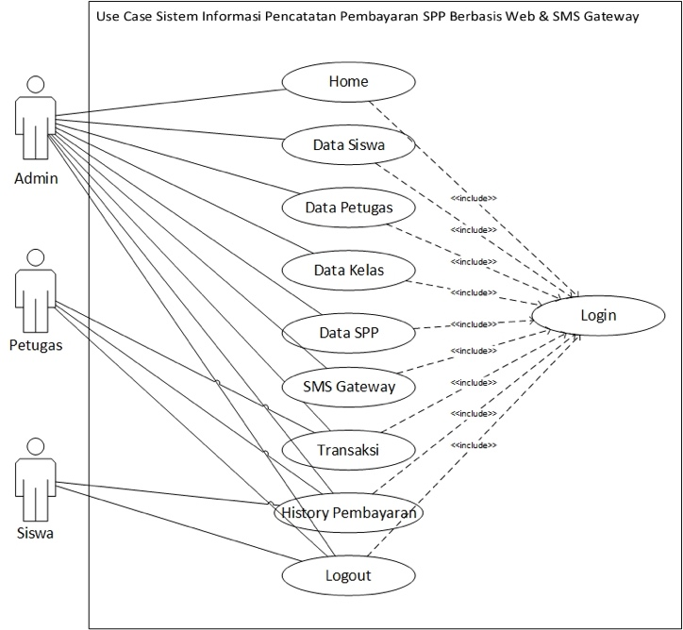
Fig2 Use Case Diagram of the SPP Recording Information System

3.2.2. Activity Diagram
The Activity Diagram design depicts the activities performed by administrators, users, and students in the tuition payment information system. These activities include the following
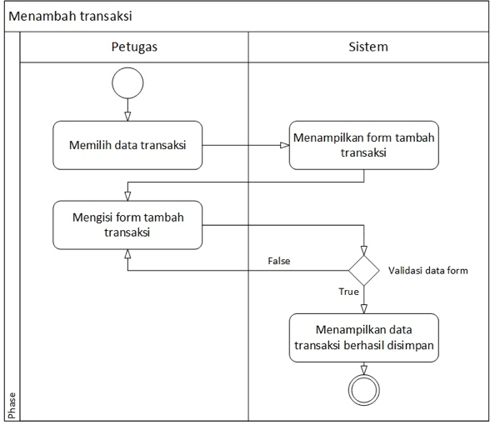
Fig.3 . Activity Diagram for Adding Transactions

3.2.3. Sequence Diagram
The sequence of events that occur in the SPP payment recording information system can be illustrated using a sequence diagram as shown in the following figure

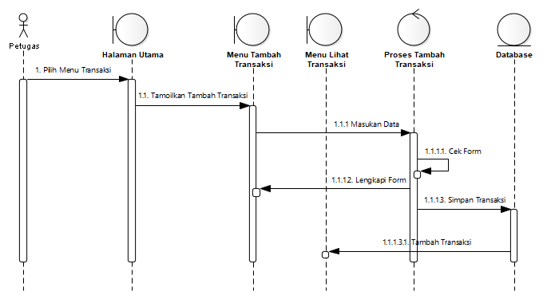
Fig4 . Sequence Diagram for Adding Transaction Data (Officer)

3.2.3. Class Diagram
In the design of the SPP payment recording information system, there are 5 interrelated classes, namely the Officer, Payment, Student, Class, and SPP classes. All existing classes have an association relationship, so that each class can influence other classes.

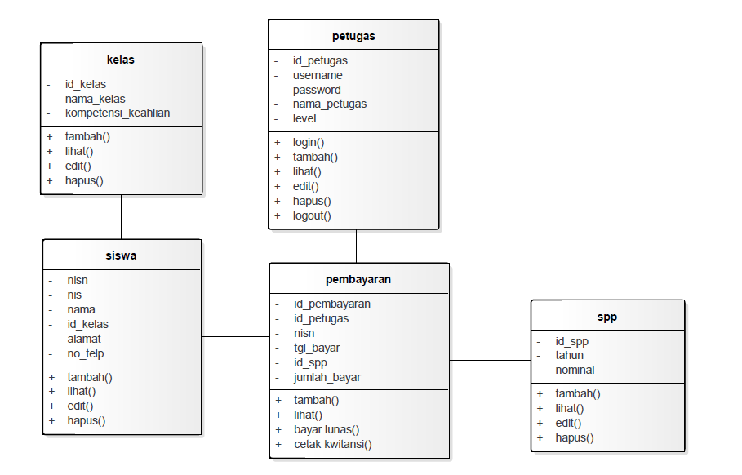

Fig5 Class Diagram for SPP Payment

3.3 Implementation Stage
3.3.1. Admin Login Page Display
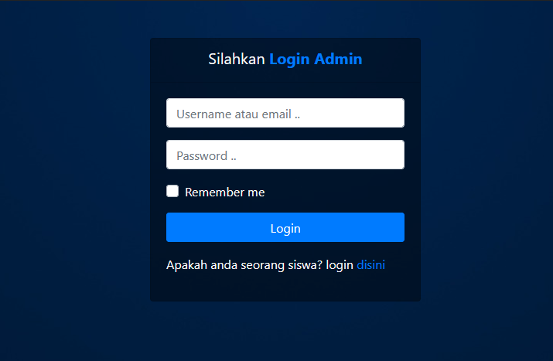
Fig6 : Admin Login Page

3.3.2. Admin Main Page Display

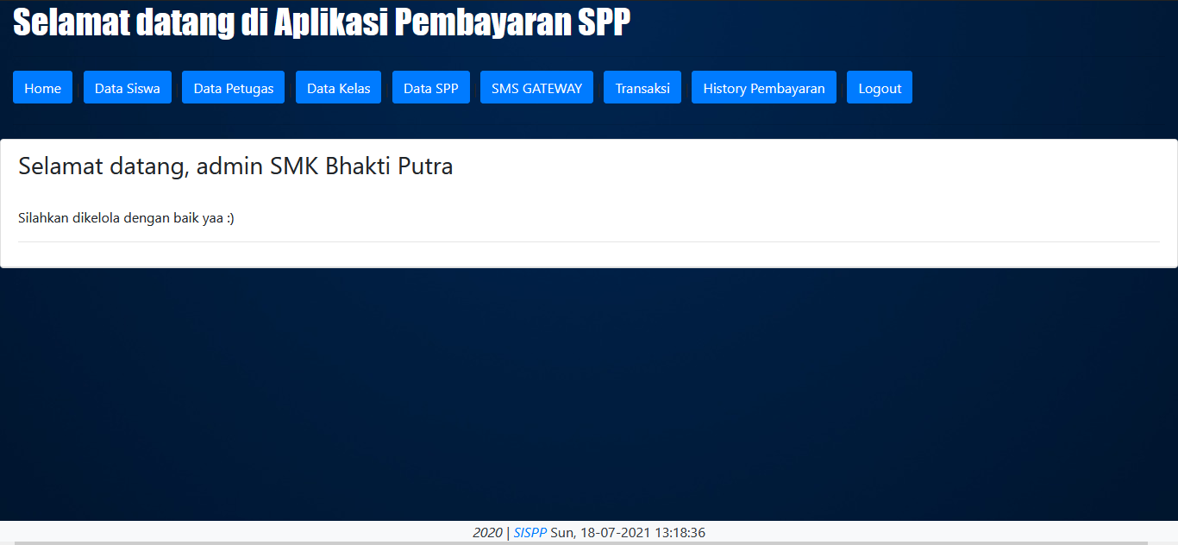
Fig7 : Admin Main Page
3.3.3. Student Data Display

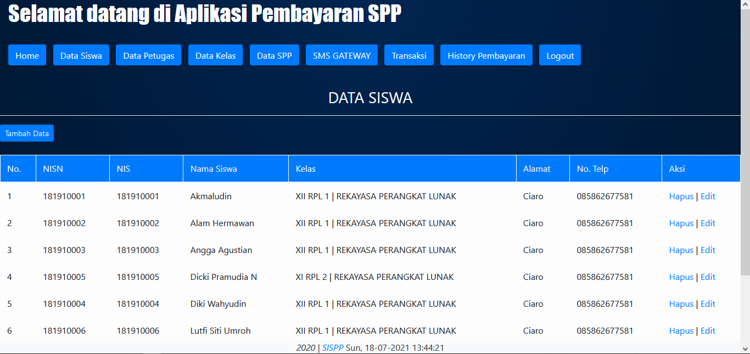
Fig8 Student Data Display Page
3.3.4. Staff Data Page Display
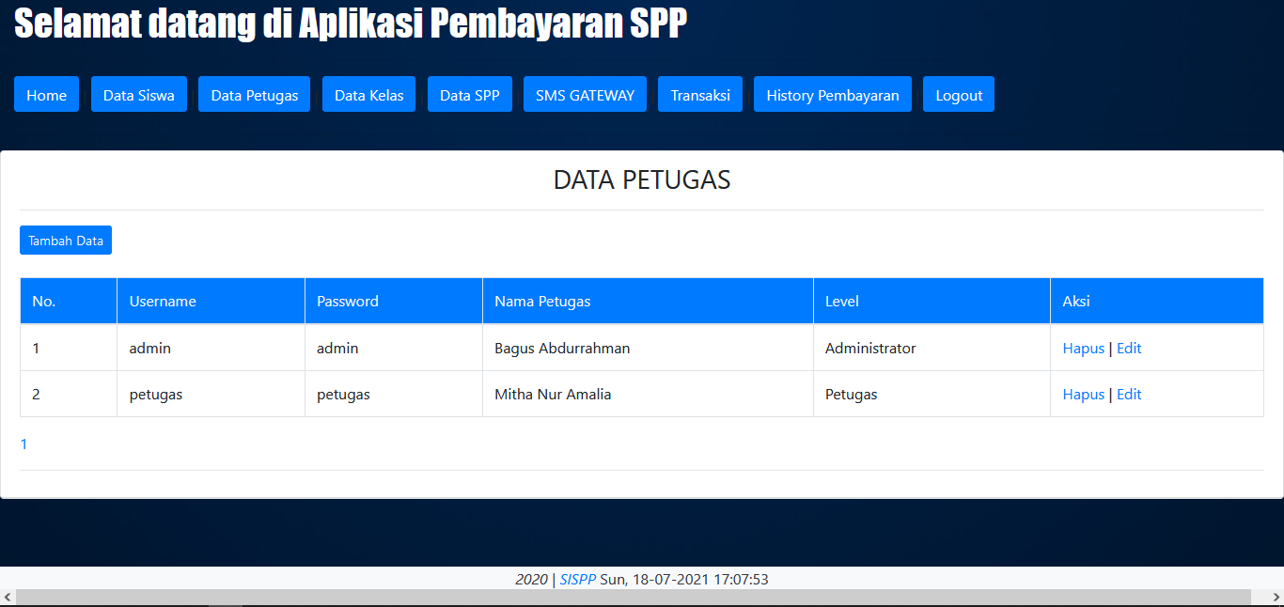
Fig9 Staff Data Page

3.3.5. SPP Data Add Page Display

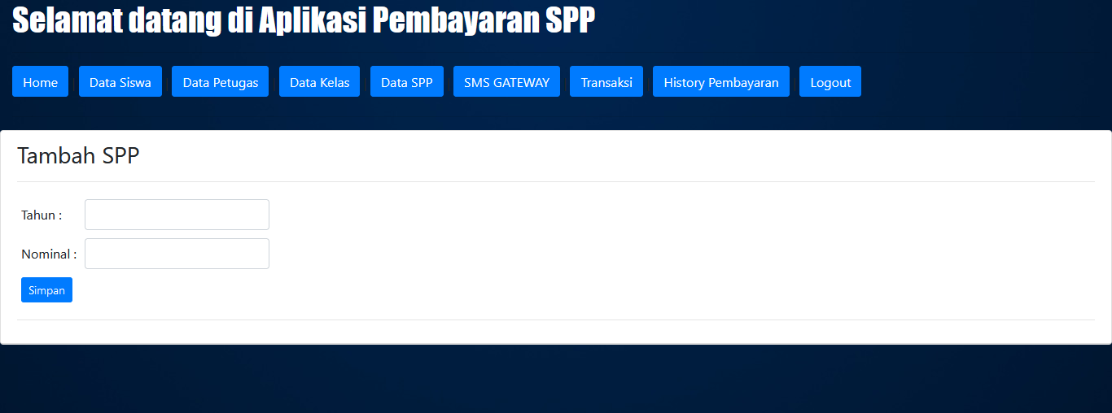
Fig10 Add SPP Data Page

3.3.6. SMS Message Send Page Display

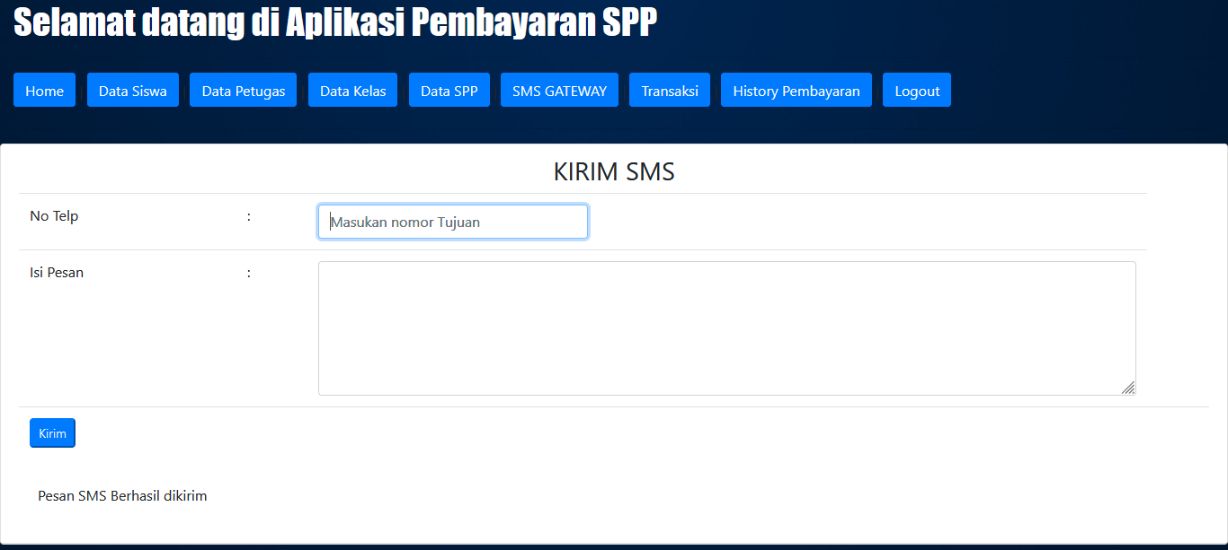
Fig11 SMS Input Page

3.3.7. SMS Message Page Display
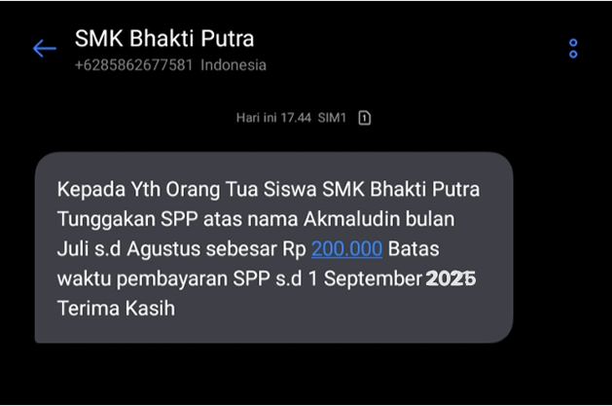
Fig12 SMS Display

3.4 System Testing Stage
This testing phase occurs when the system is deployed on the server to identify deficiencies and errors in the functioning of each system feature using black box testing techniques, which focus on software functionality[8] .

Conclusion
Based on the results of the design and implementation that has been carried out, the website-based tuition fee payment information system with SMS Gateway integration is able to improve the effectiveness and efficiency of the payment administration process in schools. This system makes it easier for schools to manage payment data, minimize recording errors, and speed up the delivery of information to parents or guardians through real-time SMS notifications. In addition, the reporting feature can support more accurate and transparent managerial decision-making. Thus, this system not only helps streamline the tuition payment process, but also improves the overall quality of school administrative services.
.

References
[1] M. Zahran Yudha, M. Kevin Perdi Hasan, M. Ichwan Athallah, and Dodo Zaenal Abidin, "Design of a Web-Based Tuition Fee Payment Information System at SMK Fania Salsabila in Jambi City," J. Inform. and Computer Engineering (JAKAKOM), vol. 3, no. 2, pp. 695–703, 2023, doi: 10.33998/jakakom.2023.3.2.1451.
[2] H. A. Ghani and D. Suhartono, “Design and Development of a WEB-Based SPP Payment Application Using the Scrum Method,” J. Ilm. IT CIDA, vol. 10, no. 1, p. 1, 2024, doi: 10.55635/jic.v10i1.204.
[3] R. Riono, A. Fitriansyah, and Y. Haryanto, “Tuition Fee Payment Information System at SMK Yaperjasa Jakarta,” J. Res. and Appl. Stud. Inform., vol. 5, no. 2, pp. 247–253, 2024, doi: 10.30998/jrami.v5i2.7296.
[4] Z. K. S, Nyangfah Nisa Septiana and Shaleh, “4Research Methods for Case Studies in a Qualitative Approach,” vol. 10, 2024.
[5] U. Jamaludin, R. Adya Pribadi, and S. Sarni, “Implementation of the Problem-Based Learning Model in Science Education to Develop Critical Thinking Skills,” Didakt. J. Ilm. PGSD STKIP Subang, vol. 9, no. 2, pp. 3247–3256, 2023, doi: 10.36989/didaktik.v9i2.1015.
[6] Y. Anis, A. B. Mukti, and A. N. Rosyid, “Application of the Waterfall Model in the Development of a Website-Based Tourism Destination Asset Information System Using Online Media), vol. 4, no. 2, pp. 1134–1142, 2023, doi: 10.30865/klik.v4i2.1287.
[7] W. Ningsih and H. Nurfauziah, “Comparison of Waterfall Model and Prototype Method for Application Development in Information Systems,” J. Ilm. METADATA, vol. 5, no. 1, pp. 83–95, 2023, doi: 10.47652/metadata.v5i1.311.
[8] S. D. Pratama, L. Lasimin, and M. N. Dadaprawira, “Black Box testing on website-based digital edu applications using equivalence and boundary value methods,” J-SISKO TECH (Journal of Information Systems and Computer Systems Technology)vol. 6, no. 2, p. 560, 2023.

