Designing a Web-Based Cake Ordering System to Increase Accessibility and Efficiency Using the Extreme Programming Method at Dapur Bolu Ibu Kokom
Grasela Asta Miranda ^{a,1*}, Tedjo Darmanto ^{b,2}, Moch Irwan Hermanto ^{b,3}
^{(a,b) (,c)}Universitas Islam Nusantara, Indonesia
¹graselagg@gmail.com ; ²tedjodarmanto2@gmail.com ; ³irwahermanto@uninus.ac.id

ARTICLE INFO |  | ABSTRACT
Article history  Received  Revised  Accepted |  | Digital transformation is driving the development of the culinary industry, including the cake and bread business. However, Dapur Bolu Ibu Kokom still uses a conventional ordering system that often leads to errors in recording orders and inefficiency of available stock. This research aims to design a web-based sponge cake ordering system to improve operational efficiency and customer satisfaction. Extreme Programming (XP) method is used to ensure the flexibility and responsiveness of the system by using javascript programming language and Unified Modeling Language system architecture design and blacbox testing system testing. The system features registration, login, ordering, stock checking, and delivery status. The results show that this system improves recording accuracy, speeds up ordering, and provides transparent stock and delivery information. Thus, the implementation of this system supports the digitalization of the culinary business and improves operational efficiency.
Keywords.
Digital transformation
sponge cake ordering
Information System
Extreme Programming

Introduction
Digital transformation has become a major force driving change in various industry sectors, including the food industry such as cakes and bakery. Technological innovation and digitalization have changed the way businesses operate, creating efficiencies and increasing the competitiveness of companies. In the cake and bakery industry, consumer demand for quality products and convenience in the ordering process continues to increase (Tulungen et al., 2022). This encourages businesses to adopt more modern information systems to optimize business operations. Based on the results of preliminary observations, it was found that the ordering process at Dapur Bolu Ibu Kokom is still carried out conventionally through direct communication or telephone which has the potential for various errors in recording orders, inefficiencies in stock management, and delays in order fulfillment.

Methods
Extreme Programming (XP) is one of the early agile methods proposed by Kent Beck in 1999 to overcome the limitations of complex software development processes in the face of frequent and rapid changes in requirements, as well as to develop methodologies suitable for object-oriented projects involving many programmers in the same location (Syafaat, 2018). According to Ferdiana in Lubis (2016), Extreme Programming (XP) is a method that explains how a technical person can develop a software efficiently by using various principles and techniques (Romney, 2015).
XP aims to improve software quality by applying software engineering concepts at an extreme level. XP has 13 key technical practices, including sitting together, complete teams, informative work environments, passionate work, pair programming, stories, short iterations, quarterly releases, free time, development in ten minutes, continuous integration, acceptance and unit test-based development, and incremental design. In addition, there are 11 supporting practices, such as root cause analysis, collective code ownership, code and test, negotiated scope contracts, real customer involvement, phased deployment, team continuity, team pruning, daily deployment, single code base, and pay-per-use practices.
2.1 Research Type and Approach
This research uses a Research and Development (R&D) approach with a case study strategy. The chosen method emphasizes the iterative and incremental nature of software development to meet dynamic user needs. Extreme Programming (XP) methodology, known for its adaptability and responsiveness to frequent changes in requirements, was applied. The XP model was chosen to accommodate the goal of building a user-friendly and efficient web-based ordering system tailored to the needs of Dapur Bolu Ibu Kokom.
2.2 Object and Scope of Research
The object of this research is a web-based cake ordering system at Dapur Bolu Ibu Kokom. This system is developed to simplify the ordering process, manage product availability, and provide real-time transaction tracking for users and administrators. This research focuses on system design and implementation, combines various user and admin functions, and falls under the domain of small-scale e-commerce applications, especially in local culinary businesses.
2.3 Data Collection Technique
Data collection in this study was carried out by means of observation and documentation. Observation was conducted to find out the workflow and ordering process at Dapur Bolu Ibu Kokom. Documentation includes requirements gathering, interface design references, and system functional specifications. These data sources inform the design and functionality of the developed application.
2.4 Tools and Materials Used
The tools used in this research include Visual Studio Code as a code editor, PHP and HTML as programming languages, MySQL as a database management system, and XAMPP as a local server environment. The system was tested on web browsers such as Google Chrome and Mozilla Firefox. The design elements were created using Figma, and the documentation was processed using Microsoft Word.
2.5 Research Procedures or Stages
This research follows the Extreme Programming (XP) methodology, which consists of four main stages: planning, design, coding, and testing.
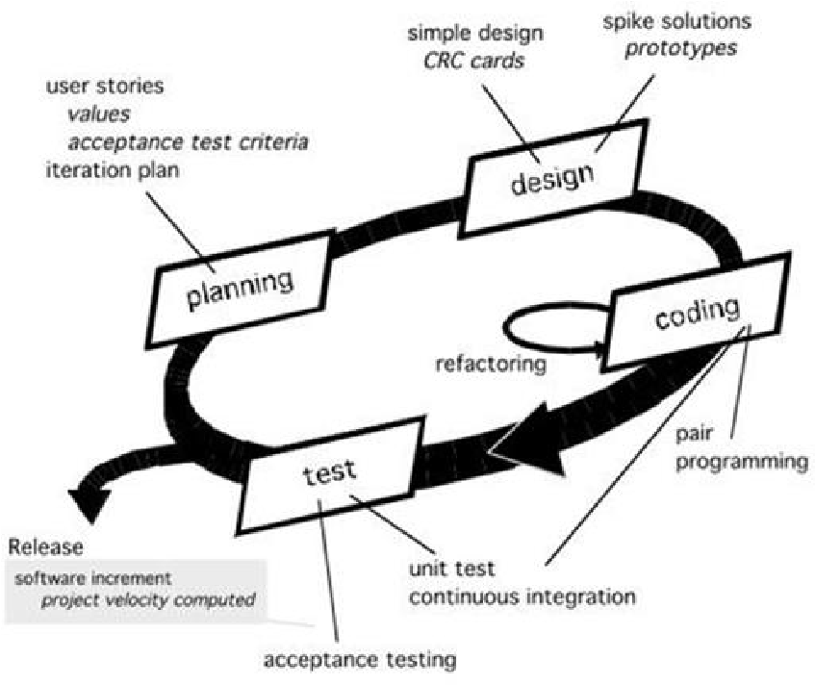
Figure 1. Extreme Programming Method
Source: https://journals.upi-yai.ac.id/index.php/ikraith-informatika/article/view/306
- Planning: Problem identification, requirements analysis, and system development scheduling.
- Design: Development of use case diagrams, flowcharts for user and admin processes, and class diagrams to model system entities.
- Coding: Implementation of system functionality based on previously designed models.
- Testing: Black-box testing is conducted to verify that each feature functions as intended. The features tested include user registration, login, product ordering, stock checking, order tracking, and logout.
2.6 Data Analysis Technique
The black-box testing method is used to analyze the functionality of the system without studying the internal code structure. Each feature is tested by providing input and observing the output to determine if it meets the expected behavior. The analysis focuses on whether the system processes data correctly, manages user roles, and handles transactions efficiently. All results are tabulated to provide a clear picture of system performance and validation.
2.7 System Design
- Usecase Diagram
Usecase diagram is a visual representation of the interaction between the system and the actors involved in the system (Pratasik & Rianto, 2020). The following is a usecase diagram of the sponge cake ordering system design at Dapur Bolu Bu Kokom.

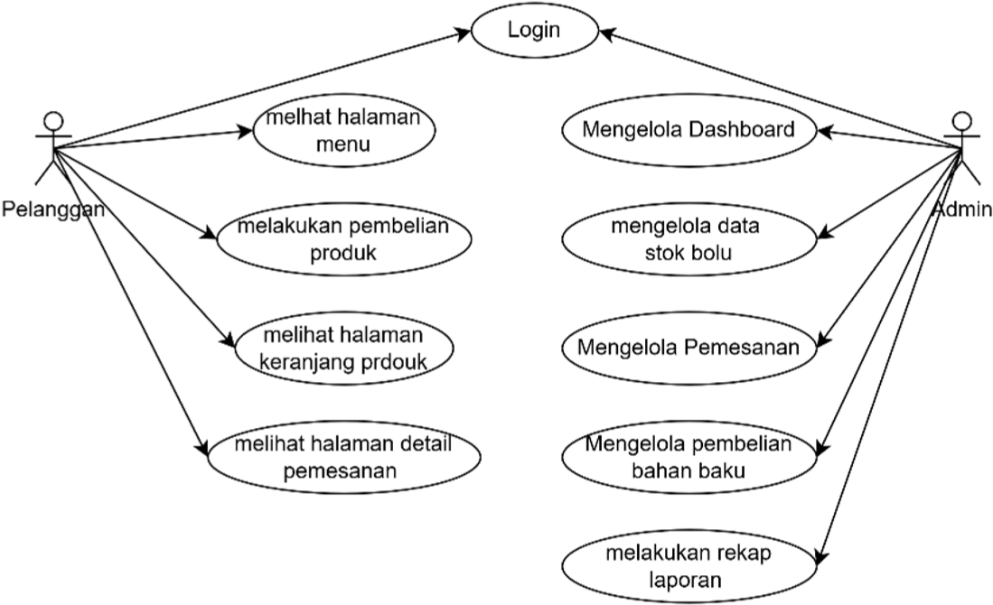

Figure 2. UseCase Diagram

- Flowchart
The flowchart is divided into two, namely for customers and admins, each of which describes the process flow of user activities in the system. In the customer flowchart, the process starts from login, then continues with decision making based on the login results. If the login fails, the customer will be asked to repeat the login process. If successful, customers can proceed to activities such as viewing the menu, viewing the product basket, viewing order details, and making product purchases. While in the admin flowchart, the process flow also starts from login with a decision whether the login is successful or not. If successful, the admin can access management features such as managing dashboards, sponge stock data, orders, raw material purchases, and recap reports.
This flowchart helps explain in detail the logical sequence of each process carried out by the user according to their respective roles. The following is a flowchart image of the explanation.
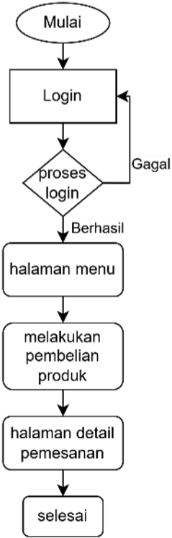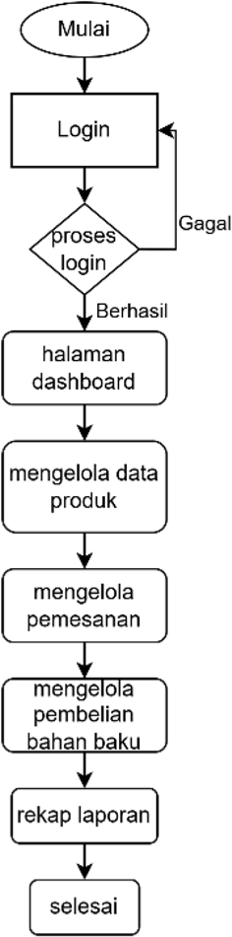

Figure 3. Flowchart

Results and Discussion
After going through the design and implementation stages using the Extreme Programming method, a web-based cake ordering system for Dapur Bolu Ibu Kokom was successfully developed. The system is designed by taking into account the needs of users (customers and admins), and adopting agile development principles so that the system can be easily customized and used efficiently.
Broadly speaking, the system consists of two main interfaces, namely the user interface and the administrator interface. The user interface includes features such as registration, login, product ordering, stock checking, shipment tracking, and transaction confirmation. While the admin interface is designed to support the process of managing product data, transactions, raw material purchases, and monthly sales reporting.
The following presents the main appearance of the system that has been built, complete with a description of each feature and its role in supporting the cake ordering business process.
3.1 Presentation of Research Results
1. Figure 3.1. User Landing Page
Landing Page is the initial display on Mrs. Kokom's sponge cake ordering system. On this initial page the user can login if they already have an account, and register if they don't have an account.
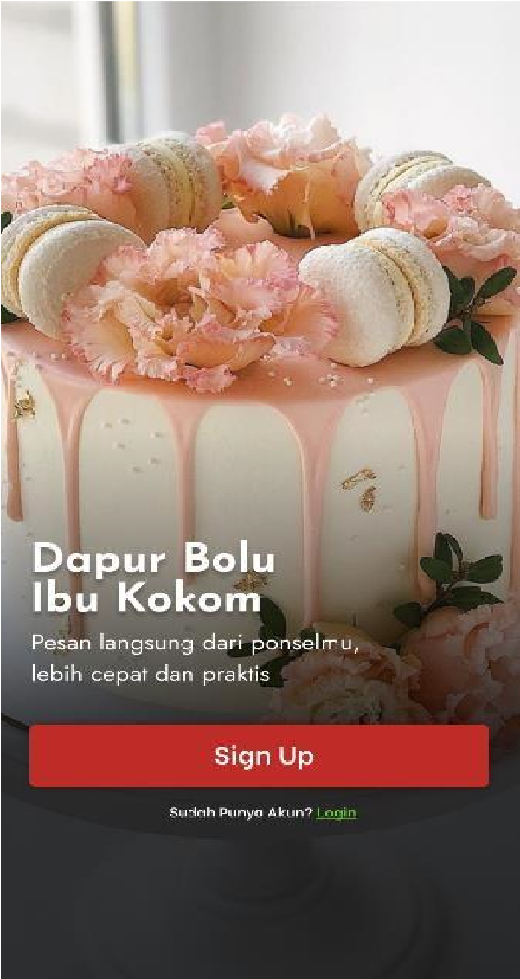
Figure 4. User's Home Page Figure 4. User's Home Page
2. Figure 5. Login Form Page
In the login form, users can enter the email and password that was created during registration to enter the system.
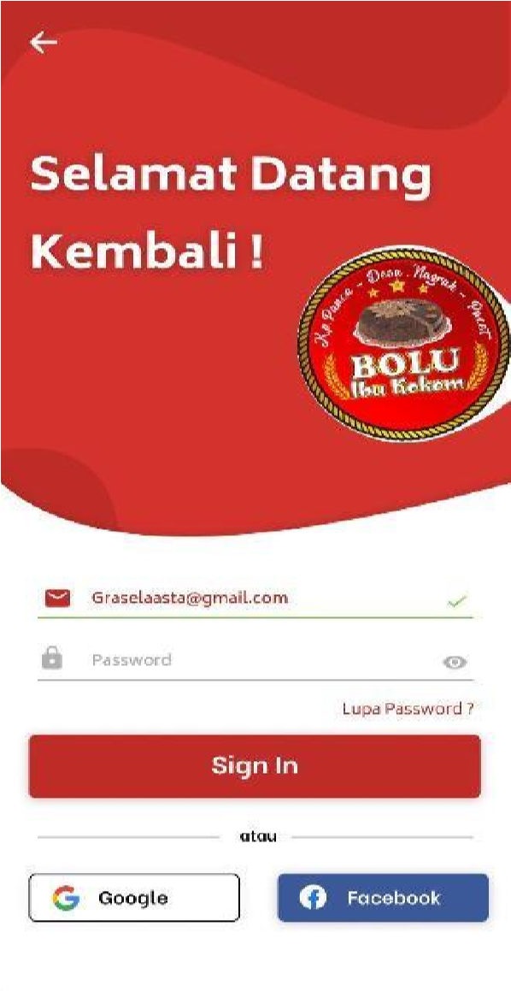
Figure 5. Login Form Page Figure 5. Login Form

3. Menu Page Display
After the user has successfully logged in, the system will redirect to the menu page which displays sponge variants, sponge prices, and sponge stock. The following is a menu view of the sponge ordering system in Mrs. Kokom's sponge kitchen.
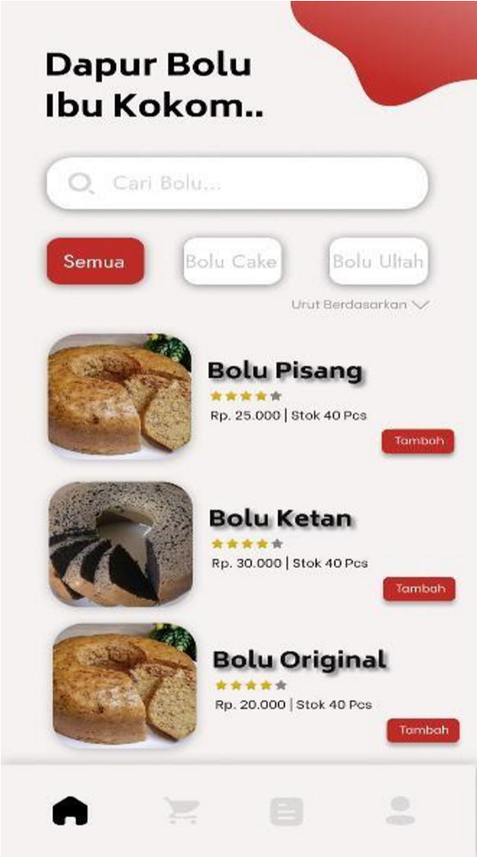
Figure 6. Menu Page Display
Then, when the customer adds a product, the view will be redirected to the details page and the number of products to be ordered.

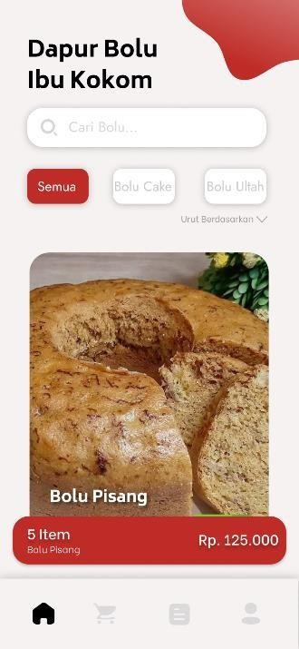
Fig. 7. Product Detail Page. Order Confirmation.

4. Product Detail Page
On the product details page explains the composition of the selected product, and users can add products.
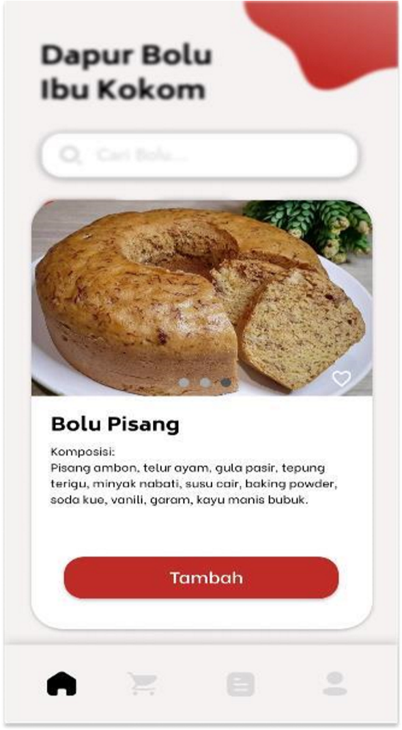
Fig. 8. Product Detail Page. Figure 8. Product Details.
5. Order Cart Page
On the order page, customers will reconfirm order details such as address, notes, and shipping services. Then customers can also reconfirm product orders and payment methods.
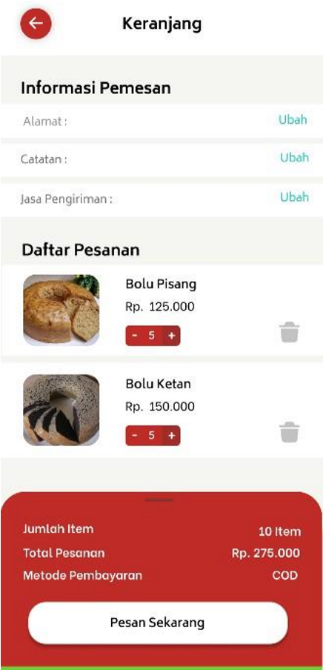
Figure 9. Order Cart Page.
After the customer confirms the order and continues the order, a successful order will appear.

Figure. Figure 10. Successful Order Confirmation

6. Order Detail Page
On this page, the user can view the order transaction history and can view the details of the order that has been placed to check the purchase status and product delivery status.
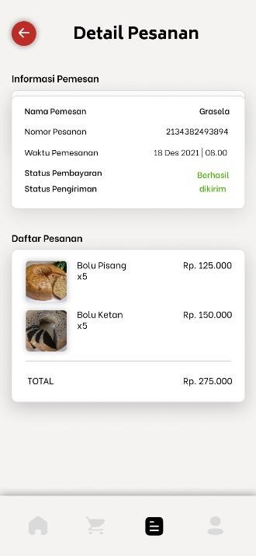
Figure 11. Order Detail Page Order Detail

7. Admin Dashboard Page
On the admin dashboard there is some data such as sponge stock, order data, raw material purchase data, manage users, and reports.
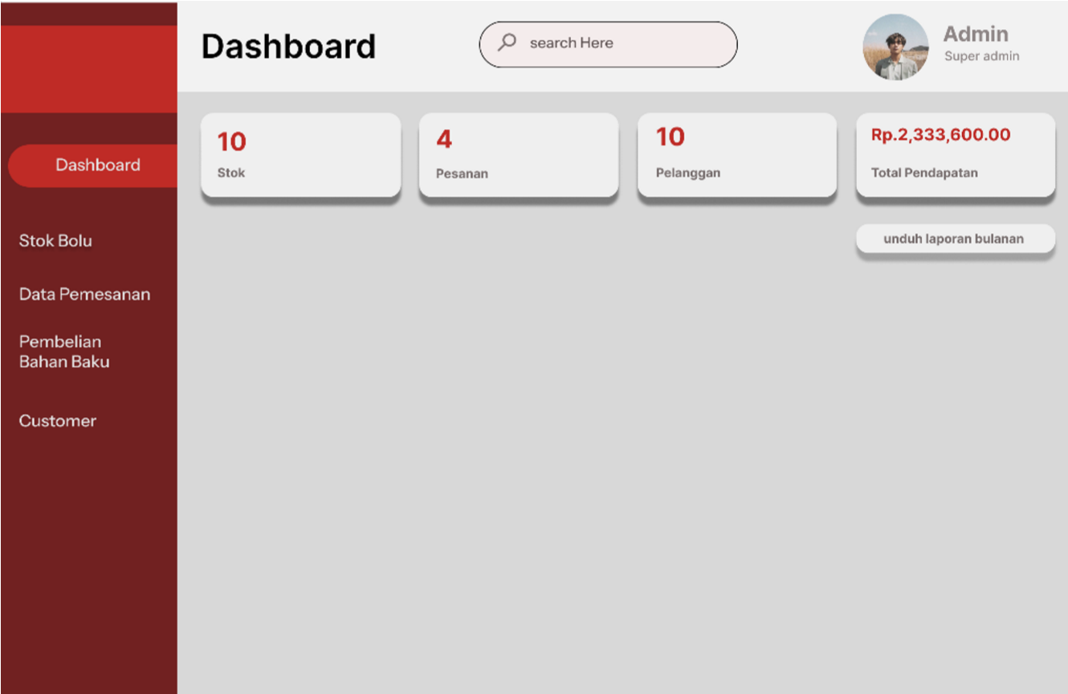
Figure 12. Figure 12. Admin Dashboard Page.
8. Sponge Cake Stock Data Page
This page displays a list of sponge cake stocks available in the system. The data presented includes information such as the name of the sponge cake, the amount of stock available, the unit price, and the product description. Admins can perform actions such as adding or deleting product data as needed.
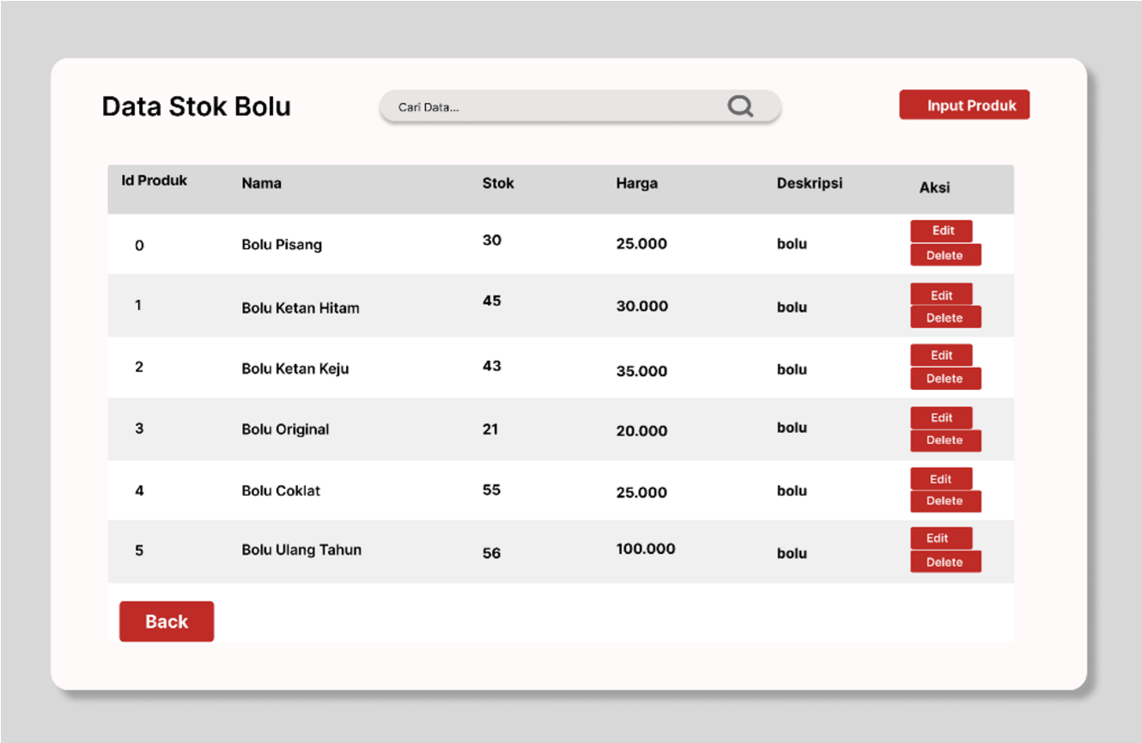
Figure 13. Product Stock Page Figure 13. Product Stock Page
9. Product Edit Page
The product edit page is used to update the sponge product information that is already available. Admins can change product names, prices, stock quantities, and product descriptions.
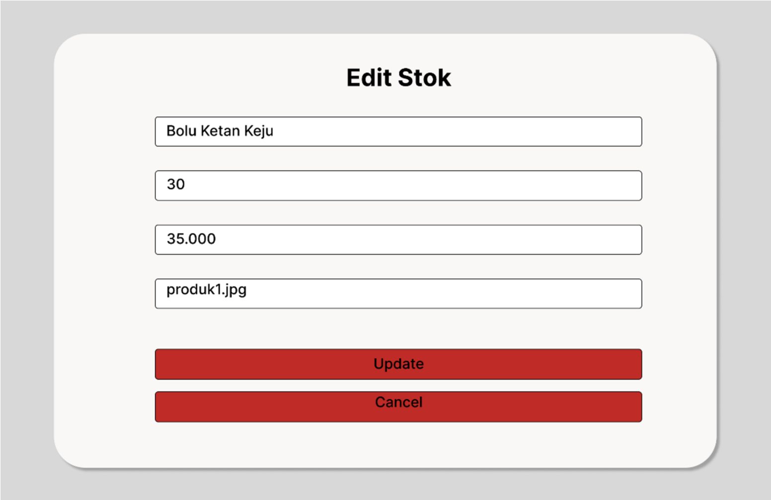
Figure 14. Product Edit Page Figure 14. Product Edit Page
10. Order Data Page
This page displays order data from customers in detail, including information such as customer name, order date, product ordered, order quantity, and total price. Admins can view order status to ensure that all transactions are recorded and processed properly.
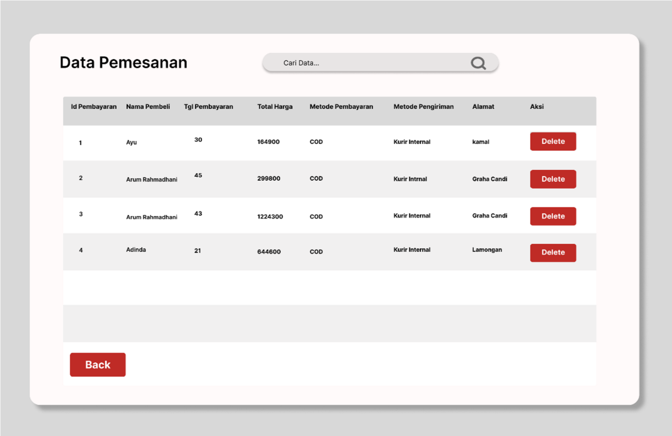
Figure 15. Order Data Page Order Data Page
11. Material Purchase Page
This page serves to record the purchase of raw materials used in the sponge cake production process. Admin can see a list of raw material purchases that have been made, along with information such as the name of the raw material, purchase amount, and purchase date.
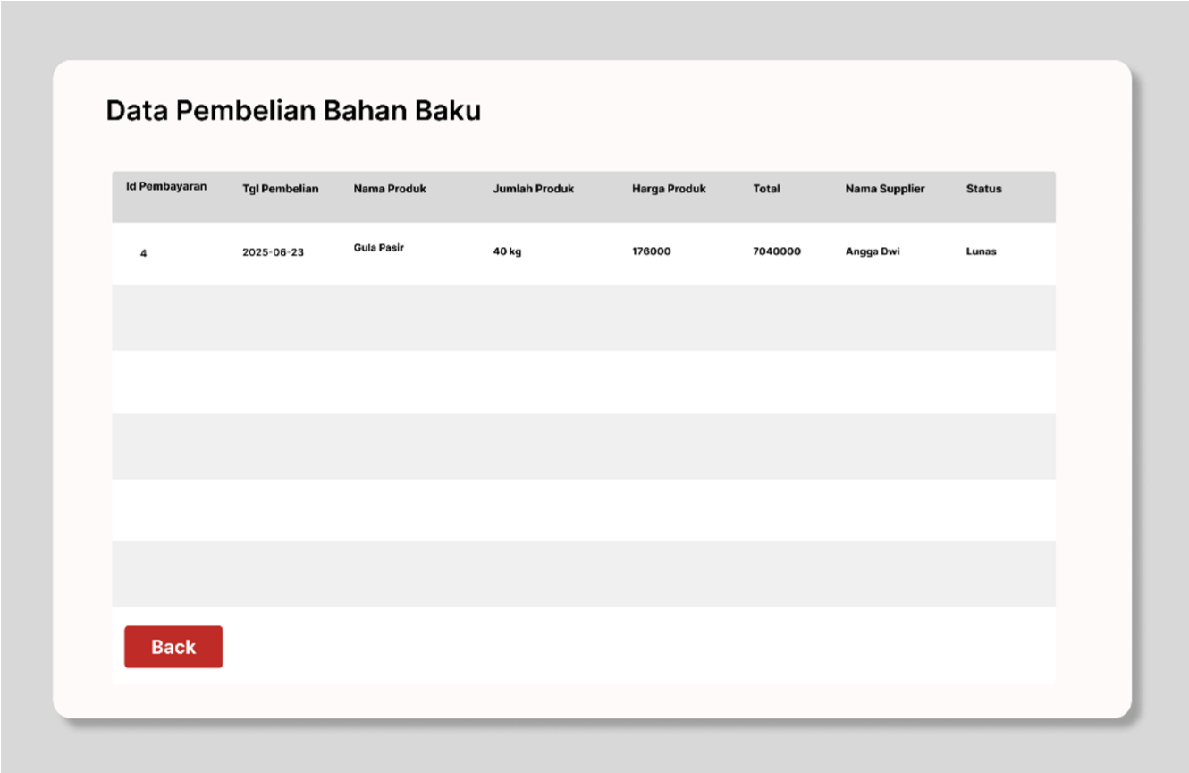
Figure 16. Raw Material Purchase Page Raw Material Purchase Page
12. Report Page
On the sales report page, the admin can download sales reports every month with the following results.
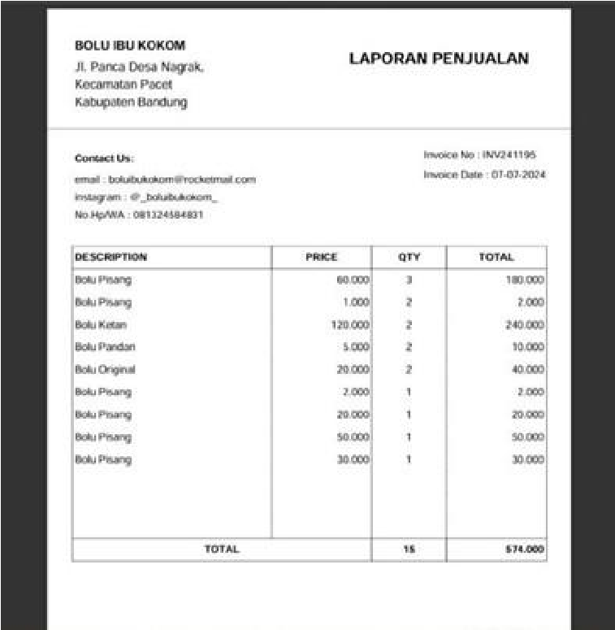
Figure 17. Sales Report Page Figure 17. Report Page
All features have passed the black-box testing stage, confirming valid functionality. Table 1 shows a summary of the test results for each main feature.
Table 1. System Testing Summary
No | Feature | Test Scenario | Test Data | Expected Result | Actual Result | Status
1 | User Registration | Fill out the registration form with valid data | Name, Username, Email, Password | The system saves the data and displays a success message | As expected | Valid
2 | User Login | Enter a valid email and password | Email, Password | System redirects to homepage | As expected | Valid
3 | Product Ordering | Select a product and fill out the order form | Chocolate Cake Product, Quantity: 2 | The system saves the order and displays the order details | As expected | Valid
4 | Stock Checking | View product stock before ordering | Chocolate Sponge Product | The system displays the available stock | As expected | Valid
5 | Order Tracking | View order status | Order ID: 1001 | System shows order status (processed/sent) | As expected | Valid
6 | Logout | Click the logout button | Click logout | System redirects to login page | As expected | Valid

3.2 Findings Analysis
The successful implementation of XP methodology enabled the development of a responsive, efficient and easy-to-use system. Simplicity of navigation and clarity of the ordering process contributed to customer satisfaction. All tested features functioned well under expected input conditions. The inclusion of real-time order tracking and admin-side management tools improved transparency and operational efficiency. Compared to conventional manual ordering, the system reduces errors and increases processing speed. These results align with the objectives of implementing an agile development model in a small business environment.
3.3 Implications of the Results
The system significantly improves the digitalization of the ordering process at Dapur Bolu Ibu Kokom. The system serves as a practical solution for small culinary businesses looking to expand their customer reach through online services. The system can be adapted by similar local businesses to streamline operations and improve customer satisfaction. From an academic point of view, this research demonstrates the applicability of the XP method in developing a small-scale e-commerce system with real user needs.
3.4 Research Limitations
Limitations of this research include the small scope of product types, reliance on local servers during development, and limited user testing outside of key stakeholders. The system is also dependent on internet availability and is not currently integrated with a third-party payment gateway. These limitations can be addressed in future development phases by expanding features, improving server infrastructure, and conducting broader usability testing.

Conclusion
The conclusion section summarizes the main findings, reflects on the research objectives, and highlights the significance of the research. This section should be written concisely, without introducing new data or analysis. A good conclusion in Informatics research restates the problem, outlines how the research addressed it, and proposes future directions or practical implementation.

References
Arifin, S. (2021). Factors Affecting Marketing Performance at the Cake and Bread Industry Center in Bugo Village. Scientific Journal of Islamic Economics, 7(2). https://doi.org/10.29040/jiei.v7i2.2550.
Dhina Pohan, S., & Firdaus, I. (2022). IMPLEMENTATION OF EXTREME PROGRAMMING METHOD IN THE DEVELOPMENT OF PEKANBARU COMMUNITY TRAINING INFORMATION SYSTEM.
PEKANBARU COMMUNITY TRAINING INFORMATION SYSTEM. In Journal of Education
Information Technology (Vol. 6, Issue 1).
Pratasik, S., & Rianto, I. (2020). Development of E-DUK Applications in HR Management Using the Agile Development Method. CogITo Smart Journal, 6(2), 204-216. https://doi.org/10.31154/cogito.v6i2.267.204-216
Romney, S. (2015). Application of Extreme Programming Method in the Design of Lecturer Teaching Credit Quota Calculation Application. IKRA-ITH Informatika, 3(1), 106-113. https://journals.upi-yai.ac.id/index.php/ikraith-informatika/article/view/306
Rozana, L., & Musfikar, R. (2020). Analysis and Design of a Web-Based Letter Filing Information System at the Dayah Tuha Village Head Office. Cyberspace:
Journal Education Technology Information, 4(1), 14. https://doi.org/10.22373/cj.v4i1.6933
Sangga Rasefta, R., & Esabella, S. (2020). Web-based Academic Information System for Smk Negeri 3 Sumbawa Besar. Journal of Informatics, Technology and Science, 2(1), 50-58. https://doi.org/10.51401/jinteks.v2i1.558
Syafaat, N. (2018). Programming MobileSmartphone and Tablet PC Applications Based on Android. Journal of Informatics Engineering, 11(1), 1-18.
Tulungen, E., Maramis, J., Saerang, D., Tulungen, E. E., Saerang, D. P., Maramis, J. B.,
Doctoral Studies in Management Science, P., Economics and Business, F., & Key, K. (2022a). DIGITAL TRANSFORMATION: THE ROLE OF DIGITAL LEADERSHIP. 1116 EMBA Journal, 10(2), 1116- 1123.
Winarti, C. (2021). Utilization of Social Media by MSMEs in Marketing Products during the Covid-19 Pandemic.
EMBA Journal, 10(1), 1-11. Yudhistira, A. S. (2021). LITERATURE REVIEW: APPLICATION OF EXTREME PROGRAMMING SOFTWARE DEVELOPMENT METHOD. https://www.researchgate.net/publication/353071239

