Design of a Raw Material Inventory Control System for the Tempe Industry Using the Economic Order Quantity (EOQ) and Quantity Discount Approach
Dafa Rizki ¹, Dian Fajarika ^{2,*}, Sherin Ramadhania ³
Industrial Engineering, Faculty of Industrial Technology, Institut Teknologi Sumatera, South Lampung, Lampung
¹ dafa.12119003@student.itera.ac.id; ² dian.fajarika@ti.itera.ac.id*; ³ sherin.ramadhania@ti.itera.ac.id
* Corresponding author

ARTICLE INFO |  | ABSTRACT
Article history  Received: October 2025  Revised: October 2026  Accepted: October 2026 |  | Planning of raw material inventory control is essential for reducing operational waste. This study aims to design a soybean raw material inventory control system at Tempe Galang Small Enterprise to minimize the potential for overstocking and stockouts. The approach used is the Economic Order Quantity (EOQ) method, taking into account quantity discounts, safety stock determination, and reorder point calculations. The research data was obtained through interviews with the SME owner and direct observation, covering demand history, order costs, storage costs, and delivery waiting times. The results show that the optimal order quantity is 69 kg per order, thereby reducing the order frequency from 141 times to 80 times per period. The safety stock level is set at 24 kg/day with a reorder point of 40 kg. The application of this method resulted in inventory cost efficiency of IDR 5,109,580 or about 8% of the previous total cost, mainly through a reduction in order frequency and the utilization of quantity discounts. In addition, the design of a semi-manual control system based on Microsoft Excel allows business actors to plan inventory independently in a more effective and efficient manner.
Keywords
Economic Order Quantity
Quantity Discounts
Safety Stock
Reorder Point
Inventory Control

Introduction
Small and Medium Enterprises (SMEs) in the food sector in Indonesia represent a labor-intensive industry with a strategic role in job creation and regional economic development [1]. In 2023, the number of SMEs in Indonesia reached 4.5 million business units, with the largest contribution coming from the food sector, accounting for 1.8 million units [2]. One of the businesses in this sector is the tempeh industries, which focuses on producing soybean-based processed products.
Tempeh is a traditional Indonesian food originating from the island of Java and is produced through the fermentation of soybeans [3]. It is widely consumed by the Indonesian population, with an average per capita consumption of 0.136 kg per week [4]. This data showed the high level of consumption has led to the rapid growth of tempeh industries in various regions. In addition to its popularity, tempeh also offers functional health benefits due to its nutritional content and bioactive compounds, which contribute to enhancing immune function, maintaining cardiovascular health, supporting brain function, fulfilling vitamin B12 requirements, and potentially preventing various diseases such as anemia, diabetes, asthma, and cancer [5].
One of the small and medium enterprises (SMEs) in Bandar Lampung City engaged in tempeh production is Tempe Galang industry. This small business unit is located in Gunung Sulah Village, Way Halim District, and has been operating since 2018. Its production capacity reaches approximately 850 pieces of tempeh per day. All business activities in this SME are still carried out manually by labor, without the use of automated machinery, including the management of raw material requirements.
Raw material inventory management plays a crucial role in maintaining the continuity of the production process. However, the practice implemented at Tempe Galang industry is still limited to estimations based on demand history from the previous month. This condition has led to several issues, such as excess inventory or overstock during the period of June–October 2024, caused by large-quantity purchasing policies triggered by concerns over rising soybean prices. Despite having a storage capacity of only 100 kg, the SME continued to purchase up to 1 ton in a single order, resulting in increased holding costs and a higher risk of raw material deterioration [6].
In response to these problems, the inventory pattern was adjusted by placing smaller but more frequent orders, specifically 15 kg every ten days from November to December 2024. However, the SME ordered 1,000 kg of raw material in June 2024, despite average demand being only 45 kg per month. This resulted in an overstock of 955 kg in that month. The maximum shelf life of soybeans is 5 months under room temperature and dry conditions. With a 5-month shelf life, quality issues arise for the unused raw materials, as the demand over 5 months amounts to only 225 kg. This situation led to overstock raw material. The order quantity was further increased to 30–45 kg per day following expansion into three new markets in 2025. This situation made the out stock raw material. Although this strategy supported increased production capacity, it also introduced new challenges, particularly stockouts due to delays in supplier distribution. This condition disrupted the production process, reduced consumer trust, and led to potential economic losses due to missed sales opportunities [7].

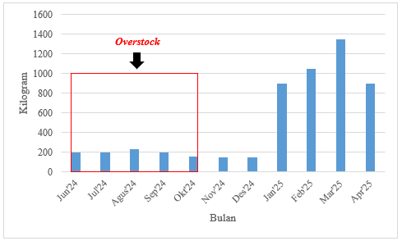
Month
- Raw Material Usage History
Problems that frequently arise in business activities are closely related to supply chain management. The sustainability of a company’s operations is highly dependent on the supply chain performance. The operation of supply chain started from the availability of adequate inventory of raw material. Raw materials are a primary component in the production process and must be consistently available to ensure the continuity of production activities [8]. Errors in inventory planning can directly affect a company’s profit levels; therefore, the achievement of business objectives is strongly influenced by the availability of raw materials [9]. The inefficiencies in raw material management can potentially disrupt the smooth flow of business processes [10]. Supply chain efficiency is not only aimed at reducing production costs but also at supporting product price stability in the market. In addition, the implementation of quantity discounts offered by suppliers is an important consideration in the ordering process. Inventory management strategies that take advantage of quantity discounts can enhance the stability of raw material availability, reduce ordering frequency, and lower holding costs as well as the risk of material deterioration [11].
The approach used to control raw material inventory is the Economic Order Quantity (EOQ) model. EOQ is a structured method for optimizing order quantities. The objective of this method is to ensure the availability of raw materials so that the production process is not disrupted by shortages or excess inventory. EOQ has been proven effective in reducing holding costs, optimizing warehouse space utilization, and minimizing the risk of overstock [12]. One variation of the EOQ method incorporates quantity discounts, a common business practice that provides incentives for companies making large-volume purchases[13]. EOQ is relevant for raw material inventory control because it can determine the optimal order quantity in terms of both quality and quantity [14]. However, the EOQ method has certain limitations, including its inability to directly calculate safety stock requirements or determine the reorder point needed to prevent supply delays that may lead to stockouts [15].
The research gap is how to design an inventory control system specifically for SMEs using the integration of EOQ with a monitoring dashboard. Current studies do not possess an inventory planning model specifically for the SME scale that can provide planning accuracy based on decisions regarding the quantity of demand data from the implementation of the EOQ framework. Furthermore, the issue of how to utilize discount factors in raw material purchasing to reduce holding costs still requires further observation.
This study aims to design an inventory control system to prevent both overstock and stockout conditions. The research gap addressed in this article lies in the planning of soybean raw material inventory using the Economic Order Quantity (EOQ) method that incorporates quantity discounts. In addition, this study focuses on determining safety stock to anticipate inventory shortages, establishing the reorder point (ROP) to identify the optimal timing for replenishment, and calculating the optimal total inventory cost. EOQ provides a baseline order quantity that minimizes the total cost of ordering and holding inventory. Even when demand fluctuates, EOQ serves as a reference point for determining reorder points and safety stock. EOQ can be extended to handle uncertainty through safety stock and reorder point (ROP) adjustment [16] . A semi-digital inventory system is designed to assist tempeh SME actors in planning the quantity of raw material purchases to cope with fluctuating demand.

Method
This study was conducted at Tempe Galang industry, located in Gunung Sulah Village, Way Halim District, Bandar Lampung City. The research employed a combination of qualitative and quantitative approaches. The qualitative approach was used to obtain data through interviews with the business owner and direct observation at the production site, while the quantitative approach involved data processing and analysis. The data collected included raw material requirements, ordering costs, holding costs, and production lead time. Observations were carried out in the production area to gain an understanding of the ongoing operational processes, including inventory management practices and the actual conditions within the SME. The qualitative data support the quantitative data to explained the data pattern exist. Qualitative data is used to determine the SME's capacity to implement EOQ and the extent to which technology transfer can be implemented for the SME's raw material requirement planning. The research was conducted through several stages, namely problem identification, data collection, data processing, results and discussion, as well as conclusions and recommendations (Fig. 2).

2.1 Problem Identification
The process of identifying the main problems in the object of study was carried out through preliminary interviews and a literature review. This stage serves as the foundation for designing an inventory control system tailored to the company’s conditions and constraints.

2.2 Data Collection Techniques
The research data were obtained from two types of sources, namely primary and secondary data. Primary data were collected through interviews, while secondary data were used to obtain supporting information from relevant literature studies.

2.3 Data Processing Techniques
The data were processed using several quantitative approaches, including the calculation of EOQ, ordering frequency, safety stock, reorder point, and total inventory cost. The methods used in this study include:
- Economic Order Quantity (EOQ). EOQ represents the most efficient quantity of inventory to be purchased each time a company places an order [17]. The formula for the basic EOQ model is expressed as follows (Jacoby, 2009). The variable D denotes the demand for tempeh, S represents the ordering cost, and H indicates the inventory holding cost.
$$Q* = \sqrt{\frac{2DS}{H}}$$ | (1)
- Ordering Frequency Calculation. The ordering frequency is determined by calculating the number of orders placed within a given period. It can be computed as the ratio between demand and the order quantity, as shown in Equation (2) [7].

$$F = \frac{D}{Q*}$$ | (2)
- Safety Stock (SS). Safety stock is used to determine the level of buffer inventory. It is calculated by multiplying the service level value (Z) by the standard deviation of demand during lead time and the average lead time (L) [18].
$$Safety Stock = Z ×σ×\sqrt{L}$$ | (3)
- Reorder Point (ROP). The reorder point is used to determine the appropriate time to place a new order
$$ROP = d×L + Safety Stock$$ | (4)
- Total Inventory Cost (TIC). Total inventory cost is determined by calculating the overall inventory cost based on the optimal order quantity. TIC is evaluated using the EOQ method when quantity discounts are applied. The calculation of TIC includes total ordering costs, holding costs, and the purchase cost[19].

$$TIC = \frac{D}{Q*}S+\frac{Q*}{2}H+P x D$$ | (5)
The service level was established based on the historical inventory performance of the SME. The appropriate service level determined from collected historical demand data and recorded the frequency of stockouts over the observation period. The actual service level was then calculated as the proportion of operating days without stockouts relative to the total number of operating days. Based on this historical calculation, a realistic and achievable target service level is 95%, which implies a maximum stockout tolerance of 5% of total operating days.

2.4 Results, Discussion and conclusion
The result presents the finding of the research objectively. This section presented factual outcomes of analyses and provide with evidence. The conclusion summarizes the results of the analysis by linking the research findings with the established objectives and provides an overview of the study’s contribution to inventory control.

Mechanism For Using Quantity Discounts (Qd)
The use of quantity discounts in the EOQ method can only be applied if several conditions are met. These include stable and predictable raw material demand in accordance with the basic assumptions of the EOQ model. The pricing structure provided by the supplier must be clear, covering both all-unit discounts and incremental discounts. All-unit discounts mean that all units receive a discounted price once a certain purchase threshold is exceeded. Incremental discounts apply only to additional units purchased beyond a certain threshold that qualify for the discounted price. The requirement for using quantity discounts (Qd) is that holding costs are proportional to the unit price. This is supported when the company has sufficient capital and warehouse capacity to carry out large-quantity purchases. In addition, purchasing decisions are based on total inventory cost, not merely the unit price [20]. The discount range involved in the observation is the result of data collection from the supplier. The supplier sets an all-unit discount of IDR 1000/kg for a minimum purchase of 50 kg up to less than 100 kg. However, a higher discount is given at IDR 20000 /100 kg. The supplier prefers all-unit discount over incremental discount because it is simpler to apply, avoids complexity in calculation, and is more profitable for the supplier in total.
The calculation stages for quantity discounts in the EOQ method include determining the initial order quantity, evaluating the calculation results, calculating total inventory cost, and selecting the order quantity [21]. The initial order quantity is determined using a simple EOQ calculation with applicable ordering and holding costs. The evaluation step considers whether the EOQ falls within a discount range; if so, that quantity is considered optimal. However, if the EOQ does not fall within a discount range, the EOQ must be recalculated using the price at the next discount level. The total inventory cost is then calculated for each relevant discount level. The final stage involves selecting the order quantity with the lowest total inventory cost among all alternatives.
Problem Indentification
Problem Identification
Data Collection Techniques
- Primary Data
- Secondary Data
Data Processing Techniques
- EOQ
- Safety Stock
- ROP

Result and Discussion
Conclusion

- Research Flow

- Results and Discussion
3.1 Characteristics of SMEs
Tempeh Galang is small and medium enterprise (SME) operating in the tempeh manufacturing. The SME located in Bandar Lampung, Lampung Province. The enterprises established in 2018 and currently maintains a daily production output of 850 pieces of tempeh. The operation of industry supported by 3 employees included the owner. The enterprise conducts its tempeh production manually including its inventory management. The annual capacity of SME is 4000 – 5500 kg of raw material. The daily procurement capacity of soybeans for this enterprise reaches 30–45 kg. The enterprise conducts its tempeh production manually, including its inventory management.

3.2 Raw Material Purchase History
The results of observations and interviews indicate that the procurement process for soybean raw materials at Tempe Galang has not been based on an optimal order quantity calculation. This inaccuracy in determining the order quantity leads to inventory inefficiency, which is reflected in the high holding costs incurred. The purchasing data of Tempe Galang is presented in Table 1.
Raw material purchases during the period from June 2024 to April 2025 were recorded at a total of 141 orders. From June to October 2024, orders were placed only once, with a quantity of 1,000 kg. This amount exceeded the available storage capacity (100 kg), resulting in excess inventory and causing raw material damage of 17 kg over five months. Subsequently, from November to December 2024, the ordering strategy changed to a frequency of 10 times per month with an average quantity of 15 kg per transaction. Entering 2025, increased production capacity led to a shift in the procurement pattern, with orders placed daily in quantities ranging from 30 to 45 kg per order.
Table 1. Raw Material Purchase Data in 2024-2025
Month | Purchase (kg) | Monthly Usage (kg) | Ending Inventory (kg) | Purchase Frequency (Times) | Raw Material Damage (%)
June 2024 | 1.000 | 200 | 800 | 1 | 1,7%
July 2024 | 1.000 | 200 | 598 | 1 | 1,7%
August 2024 | 1.000 | 230 | 363 | 1 | 1,7%
September 2024 | 1.000 | 195 | 163 | 1 | 1,7%
October 2024 | 1.000 | 153 | 0 | 1 | 1,7%
November 2024 | 150 | 150 | 0 | 10 | 0
December 2024 | 150 | 150 | 0 | 10 | 0
January 2025 | 900 | 900 | 0 | 30 | 0
February 2025 | 1.050 | 1.050 | 0 | 30 | 0
March 2025 | 1.350 | 1.350 | 0 | 30 | 0
April 2025 | 900 | 900 | 0 | 30 | 0
Total |  | 5.478 |  | 141
Average |  | 498

3.3 Ordering Cost
Ordering cost refers to the total expenses incurred in the process of procuring raw materials, including telephone costs, handling costs, and transportation costs [22]. Based on data from the past 11 months, this SME has made 141 procurement transactions, so the high ordering frequency contributes significantly to the total ordering cost.
Table 2. Ordering Cost for One Period
Component | Total Cost/  Month (IDR) | Total Ordering Cost/ Period (IDR) | FP (Times) | BP (IDR)
Phone Charge | 50.000 | 550.000 | 141 | 74.113
Freight Cost | 300.000 | 3.300.000 | 141 | 74.113
Transportation Cost | 600.000 | 6.600.000 | 141 | 74.113
Total | 950.000 | 10.450.000 | 141 | 74.113
Note: FP= Order Frequency, BP= Ordering Cost per Order
The observation results indicate that the components of ordering costs consist of telephone, transportation, and handling expenses, with an average monthly expenditure of IDR 950,000. Over one period, the total ordering cost amounts to IDR 10,450,000. Furthermore, the ordering cost per transaction is calculated by dividing the total ordering cost in one period by the number of ordering frequencies. Based on this calculation, the average ordering cost is IDR 74,113 per transaction, as presented in Table 2.

3.4 Holding Cost
Holding cost is defined as the expenses incurred as a result of raw material storage activities. The magnitude of this cost is directly proportional to the quantity of raw materials ordered; the higher the order volume, the greater the holding cost incurred within a given period, and vice versa. Holding cost SME Table 3 presents the components of holding costs for one period. The holding costs in this industry arise solely from electricity consumption used for lighting the storage area. In this SME, material handling is done manually, so depreciation of equipment cannot be calculated. The SME does not have workers dedicated to warehousing tasks; warehousing work is done by the owner and is not included in warehouse labour costs. Therefore, the most crucial cost is electricity for lighting the storage area. The installed lamp has a power rating of 30 watts and operates for 12 hours per day, resulting in an energy consumption of 0.6 kWh per day. The total holding cost from energy consumption, based on the applicable electricity tariff for one period, amounts to IDR 171,547.
Table 3. Holding Cost for One Period
Component | Electrical Power  (kWh) | Cost/ Electrical Power (IDR) | Cost/  Month  (IDR) | Cost/  Period  (IDR)
Electricity Cost | 0,36 | 1.444 | 15.595 | 171.547
3.5 Economic Order Quantity (EOQ)
The EOQ calculation is based on the total raw material requirement of Tempe Galang over one period, amounting to 5,478 kg. The parameters used in the EOQ calculation include ordering cost (S) of IDR 74,113, holding cost (H) of IDR 171,547, and a raw material demand of 5,478 kg per period. The comparison of optimal order quantities before and after the implementation of EOQ is presented in Table 4. The results (Table 4) indicate that the optimal order quantity for raw materials is 69 kg per order.
Table 4. Optimal Order Quantity of Raw Material
Condition | Optimal Order Amount  (kg) | Order Frequency  (Times)
After implementation EOQ | 69 | 80
Before implementation EOQ | 39 | 141

3.6 Determination of The Amount of Inventory to Prevent Uncertainty
The calculation of the inventory level required to anticipate demand fluctuations is presented in Table 5. The safety stock (SS) is calculated at 24 kg per day, which represents the minimum buffer inventory that must be maintained to prevent stockouts during demand fluctuations or supply delays. This buffer ensures continuity in production despite variability in usage. The reorder point (ROP) is determined to be 40 kg. This indicates that a new order should be placed when the inventory level reaches 40 kg. At this level, the remaining stock is sufficient to cover demand during the lead time, while also maintaining the safety stock level.
Table 5. The Amount of Inventory to Prevent Uncertainty
Component | Total Inventory/ Day | Unit
Safety Stock (SS) | 24 | Kg
Reorder Point (ROP) | 40 | Kg

3.7 Comparison of Existing TIC and Optimization
The raw material ordering system at Tempe Galang was previously carried out manually by relying on estimated requirements based on historical usage. This mechanism often led to inaccuracies in procurement, resulting in both overstock and stockouts, as well as high total inventory costs. One case occurred in June 2024, when the SME purchased 1 ton (1,000 kg) of soybeans at a price of IDR 9,500/kg in anticipation of a price increase. However, this decision had a negative impact in the form of excess inventory accumulation. In response, the SME then shifted to a daily purchasing pattern. Nevertheless, this new strategy also created another issue, namely stockouts due to delays in delivery from suppliers.
The research uses two schemes of scenario. First, the SME did not utilize the quantity discount scheme offered by the supplier during one period of raw material ordering. Second, the supplier provided two pricing options: IDR 10,500/kg for purchases below 50 kg, and a discount of IDR 1,000/kg for purchases of at least 50 kg, with a maximum discount limit of IDR 20,000 per quintal. This quantity discount scheme has been in effect since early 2025. The comparison of total inventory cost (TIC) under existing conditions and after optimization is presented in Table 6.
Table 6. Optimal Order Quantity of Raw Material
Component | Q_{opt}  (kg) | FP (Times) | BP  (IDR) | BS  (IDR) | RM  (IDR) | TIC  (IDR)
Optimization | 69 | 80 | 5.929 | 171 | 55.930 | 62.030
Existing | 39 | 141 | 10.450 | 171 | 56.519 | 67.140
Difference | 30 | 61 | 4.520 | 0 | 588 | 5.109
(%) | 43% | 43% | 43% | 0 | 1% | 8%
Note: Q_{opt} = Optimal Order Quantity, FP= Ordering Frequency, BP= Ordering Cost, BS=Holding Cost, RM= Raw Material Cost, TIC= Total Inventory Cost.
Optimization that considers quantity discounts results in a reduction in ordering frequency from 141 times to 80 times, with an optimal order quantity of 69 units (Table 6). Ordering costs decreased by IDR 4,520,960 or 43%, while savings in raw material costs reached IDR 588,620. Overall, the total inventory cost (TIC) decreased by IDR 5,109,580, equivalent to an 8% reduction compared to the pre-optimization condition.

3.8 Proposed Inventory Control System
This stage is carried out to design a semi-manual inventory control system, which is recommended as a solution to reduce the risk of overstock, stockouts, and inaccuracies in determining order quantity and frequency. The proposed system includes mechanisms for recording demand, calculating optimal order quantity using the EOQ method, determining ordering intervals, setting safety stock, identifying the reorder point, and estimating total inventory costs. All design procedures are facilitated through the use of Microsoft Excel, enabling SME owners to implement the inventory control system independently and in a structured manner.
The inputs for the system are holding cost per unit per year (HC), ordering cost per year (OC), order quantity (Q), annual demand in units (D), price per unit (P), ordering cost per order (S), and holding cost per year (H). These inputs are used to calculate the outputs, namely the optimal number of units per order (Q*) using the EOQ method, total cost (TC), order frequency over one year (F), safety stock, reorder point (ROP), and total inventory cost (TIC). These output calculations use the formulas presented in subsection 2.3.
- The Design of Raw Material Demand History
The design of a raw material demand history recording system serves as a solution to inventory control problems arising from the absence of prior demand documentation (Fig. 3).

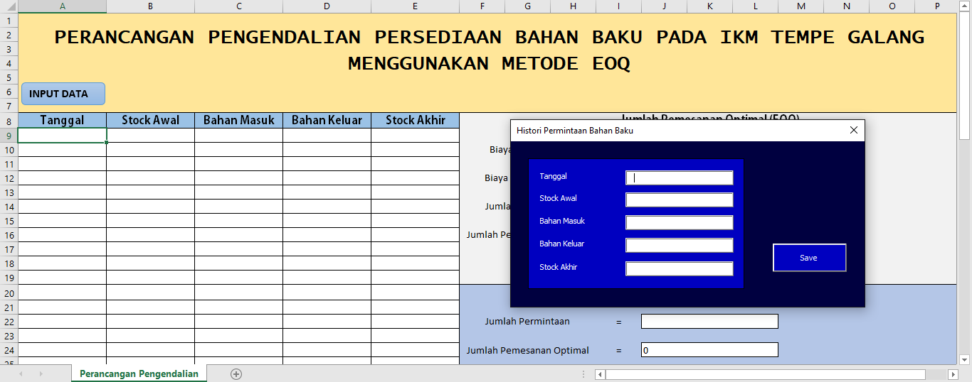
- Designing The Recording of Raw Material Requests
- Design of EOQ Calculation Menu
This design is intended to determine the optimal order quantity independently, thereby reducing the total inventory costs incurred (Fig. 4).

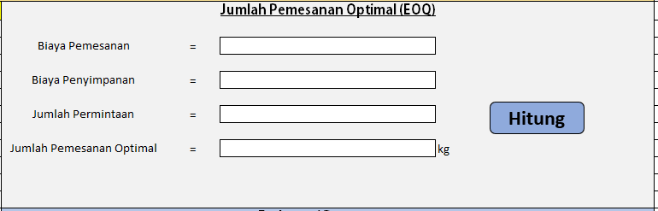
- Menu Display for Determining Optimal Number of Orders
- Design of the Ordering Frequency Display Menu
This design aims to determine the ordering frequency independently in order to improve accuracy in planning raw material requirements (Fig. 5).

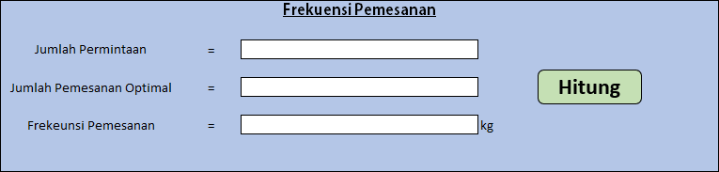
- Order Frequency Display Menu
- Design of the Safety Stock Calculation Menu
This design is focused on determining the appropriate level of safety stock independently to anticipate the risk of stockouts due to uncertainty in the raw material procurement process (Fig. 6).

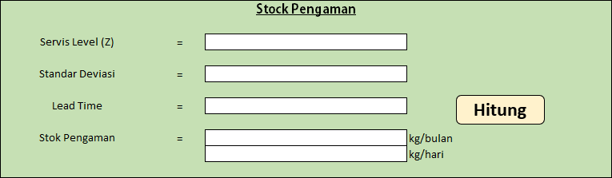
- Designing The Determination of Safety Stock
- Design of Reorder Point Determination
This design functions to establish the minimum level of raw material inventory that must be maintained by the SME owner. In addition, this application helps determine the appropriate time for reordering by identifying the minimum quantity of raw materials at which a reorder should be placed independently (Fig. 7).

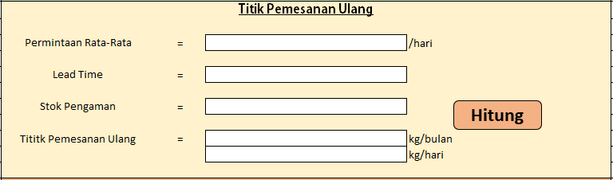
- Designing The Determination of Reorder Pont
- Design of The Total Inventory Cost Calculation System
This design functions to assist business owners in calculating the total inventory costs incurred, as well as to facilitate the monitoring and control of inventory costs as a basis for making more efficient and independent raw material procurement decisions (Fig. 8).

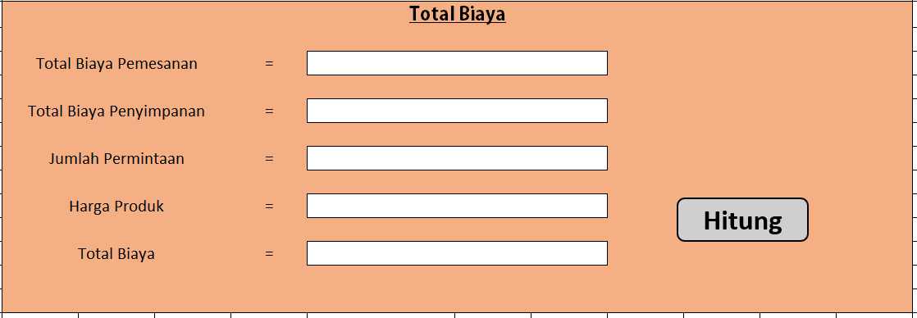
- Menu Display of Total Inventory Cost Determination
Field testing of the system was conducted directly at the UKM Tempe Galang. The owner was asked to input the raw materials purchased. The results showed that the owner and 2 employees were able to use this application. After conducting usability testing by providing instructions for filling in the target service level, demand standard deviation, lead time, and average demand, it was found that the task success rate was ≥ 90%, with a completion time per form of < 2 minutes and an error rate of < 10%.
3.8 Sensitivity Analysis
The base-case values are listed in Table 8. The average daily demand is the total usage of 5,478 kg divided by 328 working days, and σ is the standard deviation of monthly usage (432 kg) divided by 30 days. The results of the one-way analysis are given in Tables 9 and 10 and in Fig. 9.
Table 8. Base-Case Parameter Values Used in the Sensitivity Analysis
Parameter | Symbol | Base-case value
Demand | D | 5,478 kg per period
Ordering cost | S | IDR 74,113 per order
Holding cost | H | IDR 171,547 per period
Average daily demand | d | 16.7 kg per day
Standard deviation of daily demand | σ | 14.4 kg per day
Lead time | L | 1 day
Service level | Z | 95% (Z = 1.65)
Unit price and discount | P | IDR 10,500/kg; discount of IDR 1,000/kg for Q ≥ 50 kg, limited to IDR 20,000 per order
Storage capacity | – | 100 kg
Note: d = D/328 working days; σ = standard deviation of monthly usage (432 kg) divided by 30 days.
Table 9 shows that Q* responds moderately to changes in D, S, and H. Since Q* varies with the square root of these parameters, a 20% change moves the optimal quantity by roughly 10%, from 62 to 75 kg for D and S and from 63 to 77 kg for H. The ordering frequency stays between 71 and 89 orders per period, against 80 in the base case and 141 in the existing pattern, and Q* remains above the 50 kg discount threshold in every case. The maximum stock stays within the 100 kg capacity except when H is 20% lower, where it reaches 100.8 kg. The reorder point, which depends on D through the daily demand, ranges from 37 to 44 kg when D changes by ±20%.
Table 9. Sensitivity of the Order Policy to Demand, Ordering Cost, Holding Cost, and Discount Limit
Parameter | Change | Q* (kg) | FP (times) | TIC (thousand IDR) | ΔTIC (%) | Saving vs. existing (%) | Q* + SS (kg)
Base case | – | 69 | 80 | 62,030 | 0.0 | 7.6 | 92.8
Demand (D) | −20% | 62 | 71 | 50,033 | −19.3 | – | 85.8
Demand (D) | −10% | 65 | 76 | 56,052 | −9.6 | – | 88.8
Demand (D) | +10% | 72 | 84 | 67,992 | +9.6 | – | 95.8
Demand (D) | +20% | 75 | 87 | 73,887 | +19.1 | – | 98.8
Ordering cost (S) | −20% | 62 | 89 | 61,197 | −1.3 | 5.9 | 85.8
Ordering cost (S) | −10% | 65 | 84 | 61,606 | −0.7 | 6.8 | 88.8
Ordering cost (S) | +10% | 72 | 76 | 62,363 | +0.5 | 8.5 | 95.8
Ordering cost (S) | +20% | 75 | 73 | 62,720 | +1.1 | 9.4 | 98.8
Holding cost (H) | −20% | 77 | 71 | 61,493 | −0.9 | 8.4 | 100.8
Holding cost (H) | −10% | 73 | 76 | 61,805 | −0.4 | 7.9 | 96.8
Holding cost (H) | +10% | 66 | 84 | 62,273 | +0.4 | 7.3 | 89.8
Holding cost (H) | +20% | 63 | 87 | 62,436 | +0.7 | 7.1 | 86.8
Discount limit (IDR per order) | 0 | 69 | 80 | 63,619 | +2.6 | 5.2 | 92.8
Discount limit (IDR per order) | 10,000 | 69 | 80 | 62,825 | +1.3 | 6.4 | 92.8
Discount limit (IDR per order) | 30,000 | 69 | 80 | 61,236 | −1.3 | 8.8 | 92.8
Note: Q* = optimal order quantity (rounded to 1 kg); FP = ordering frequency; TIC = total inventory cost (truncated to thousand IDR, as in Table 7); SS = safety stock (24 kg in all rows). Saving = reduction in TIC relative to the existing purchasing pattern, recalculated with the changed S or H. It is not shown for D because the existing pattern refers to the observed demand. Bold in the last column = maximum stock above the 100 kg storage capacity.
Total inventory cost is much more sensitive to demand than to the cost parameters. Raw material cost accounts for about 90% of TIC, so TIC changes almost in proportion to D (−19.3% to +19.1% for ±20%), whereas ±20% changes in S or H alter TIC by no more than 1.3%. Across the S, H, and discount-limit scenarios the saving relative to the existing pattern stays positive and lies between 5.2% and 9.4%, compared with 7.6% in the base case (rounded to 8% in Table 7). The lowest value occurs when no discount is given. TIC then rises to IDR 63,619 thousand, but the optimized policy is still cheaper than the existing pattern, mainly because of the lower ordering cost.
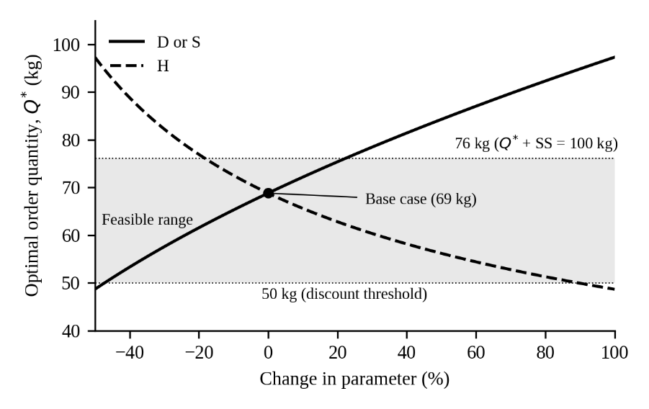
- Effect of Changes in D, S, and H on the Optimal Order Quantity
Fig. 9 extends the analysis beyond ±20%. Two limits mark the region in which a quantity near 69 kg remains valid. The first is the discount threshold: Q* falls below 50 kg if H increases by about 89%, or if D or S decreases by about 47%. The second is storage: with SS = 24 kg, the maximum stock reaches 100 kg when Q* = 76 kg, which happens if D or S rises by about 23% or H falls by about 19%. The holding cost needs particular care because it covers only the electricity used for lighting (Section 3.3). If the deterioration loss recorded in 2024 (IDR 161,500) were added to H, giving IDR 333,047, Q* would drop to 49 kg. This lies in the lower price level, and a comparison of TIC at 49 kg and at the 50 kg threshold, following Section 2.5, favors 50 kg (IDR 63,813 thousand against IDR 66,152 thousand).
Table 10 gives the safety stock and reorder point for different service levels and lead times. Raising the service level from 90% to 99% increases SS from 18 to 34 kg and ROP from 35 to 50 kg when L = 1 day. Lead time has a larger effect. At the 95% service level, ROP increases from 40 kg to 67 kg when L = 2 days and to 91 kg when L = 3 days, because both the demand during lead time and the safety stock become larger. Storage capacity is the binding constraint. With Q = 69 kg, the maximum stock exceeds 100 kg for L = 3 days at every service level, for L = 2 days at service levels of 95% or higher, and for the 99% service level even when L = 1 day.
Table 10. Safety Stock and Reorder Point at Different Service Levels and Lead Times
Service level (Z) | Lead time
Service level (Z) | L = 1 day | L = 2 days | L = 3 days
90% (Z = 1.28) | 18 / 35 | 26 / 59 | 32 / 82
95% (Z = 1.65) | 24 / 40 | 34 / 67 | 41 / 91
97.5% (Z = 1.96) | 28 / 45 | 40 / 73 | 49 / 99
99% (Z = 2.33) | 34 / 50 | 47 / 81 | 58 / 108
Note: each cell shows SS / ROP in kg. Bold = maximum stock (Q* + SS, with Q* = 69 kg) above the 100 kg storage capacity. The base case is a 95% service level with L = 1 day.
The order quantity is therefore stable against moderate errors in D, S, and H, while the buffer stock and the storage limit are much more sensitive to supplier lead time. For Tempe Galang, the 69 kg policy with a reorder point of 40 kg remains workable if deliveries take one day, but smaller orders or additional storage would be needed if deliveries are delayed by a further day.

3.9 Discussion
The EOQ method is used to support decision-making in determining the most efficient raw material order quantity by considering historical demand data, ordering costs, and holding costs. The use of the EOQ method is justified by the occurrence of both overstock and stockouts in the SME. Raw material purchases from 2024 to 2025 show a significant discrepancy in quantities, resulting in excessive accumulation from June to October 2024 and an increase in raw material demand in 2025. This condition led to irregular raw material inventory levels, highlighting the need for a strategy to prevent stockouts and overstock.
The results of the EOQ calculation indicate that the optimal order quantity for raw materials is 69 kg per order (Table 4). This figure is 30 kg higher than the pre-optimization condition, which was only 39 kg. The increase in order quantity results in a reduction in ordering frequency from 141 times to 80 times within one period. This change provides benefits to the SME by significantly reducing total ordering costs.
However, the EOQ approach has limitations, as it cannot fully address uncertainty in the raw material procurement process [23]. Therefore, additional mechanisms such as safety stock (SS) and reorder point (ROP) are required. Safety stock is established to maintain raw material availability under fluctuating demand conditions, thereby minimizing the risk of stockouts [24]. Meanwhile, the reorder point is used to determine the minimum inventory level at which a reorder should be placed to ensure a continuous supply [25]. The calculation of inventory levels required to anticipate demand fluctuations is presented in Table 5.
The calculation of safety stock (SS) and reorder point (ROP) shows that the SME must maintain a minimum inventory level (SS) of 24 kg/day in storage. When the inventory level drops to 40 kg (ROP), a reorder must be placed immediately to avoid the risk of stockouts due to potential supply delays. These calculations provide practical guidance for the SME in optimizing raw material inventory levels.
The implementation of the EOQ method by incorporating quantity discounts provides a positive impact on cost efficiency. The optimization reduces the ordering frequency from 141 times to 80 times, with an optimal order quantity of 69 units. Ordering costs decrease by IDR 4,520,960 or 43%, while savings in raw material prices reach IDR 588,620. A comparison of total inventory costs (TIC) under existing conditions and after applying EOQ shows that overall inventory costs decrease by IDR 5,109,580, equivalent to an 8% reduction compared to pre-optimization conditions. These findings indicate that the application of the EOQ approach integrated with quantity discounts is effective in improving the efficiency of raw material inventory control systems in SMEs. This optimization not only reduces inventory costs but also supports the sustainability of raw material availability for the production process.

Conclusion
The design of a raw material inventory control system at SME Tempe Galang using the EOQ method improves performance, particularly in reducing ordering frequency. The EOQ results indicate that the optimal order quantity is set at 69 kg per transaction. The implementation of this policy reduces the ordering frequency from 141 orders to 80 orders per period, thereby making the inventory management process more efficient. This study also provides a means to anticipate supply uncertainty by establishing a safety stock requirement of 24 kg per day and a reorder point of 40 kg.
The optimization of raw material inventory using EOQ demonstrates improved performance in reducing inventory cost inefficiencies. This is evidenced by an 8% reduction in inventory costs through the application of quantity discounts. This efficiency is achieved through reduced ordering frequency, increased order quantity per cycle, and the utilization of quantity discount incentives.
Future research may focus on developing inventory control models by comparing various methods, such as Lot-for-Lot (LFL), the Periodic Review System, and the Minimum-Maximum System, to identify the most efficient approach to inventory management. The scope of research can also be expanded by incorporating costs associated with stockouts, including lost sales, decreased customer trust, and emergency ordering costs, so that the estimation of total inventory cost becomes more comprehensive and realistic. In addition, model development can be directed toward integrating seasonal demand factors and lead time uncertainty, enabling the inventory control system design to be more adaptive to dynamic operational environments.

Acknowledgment
The authors would like to express their sincere gratitude to Tempe Galang industry, the research team, and all parties who have contributed to the preparation of this journal.

Declarations
Author contribution. Conceptualization, Dian Fajarika.; methodology, software, validation, formal analysis, investigation, resource, data curation, and writing—original draft preparation, Dafa Rizki.; writing—review, editing, and supervision, Sherin Ramadhania. All authors have read and agreed to the published version of the manuscript.
Funding statement. This research received no external funding sources.
Conflict of interest. The authors declare no conflict of interest.
Additional information. No additional information is available for this paper.

Data and Software Availability Statements
The data processing conducted by the authors was carried out using Microsoft Excel and Microsoft Word. Microsoft Excel was used for data processing and for designing a semi-automated inventory control system, while Microsoft Word was used to record data obtained from interviews with the SME owner. The following is a Google Drive link containing the data used in the preparation of this journal, which can be accessed publicly.
https://drive.google.com/drive/folders/1BkbY9bszhbWbFm5n9kPyqMlWFAxLD24U?usp=sharing

References
[1] R. D. Kristianti, M. R. A. C. Chusen, and M. Yasin, “Analisis Pola Spasial Industri Kecil Menengah (Ikm) Dan Industri Rumah Tangga (Irt) Di Kabupaten Dan Kota,” POPULER: Jurnal Penelitian Mahasiswa, vol. 3, no. 4, pp. 55–66, 2023, doi: 10.61722/jiem.v3i4.4380.
[2] Badan Pusat Statistik, “Profil Industri Mikro dan Kecil 2023,” 2023.
[3] O. H. Kristiadi and A. T. Lunggani, “Tempe Kacang sebagai Pangan Fermentasi Unggulan Khas Indonesia: Literature Review,” Jurnal Andaliman-Jurnal Gizi Pangan, Klinik Dan Masyarakat, vol. 2, no. 2, pp. 48–56, 2022, doi: https://doi.org/10.24114/jgpkm.v2i2.40334.
[4] Badan Pusat Statistik, “Rata-Rata Konsumsi per Kapita Seminggu Beberapa Macam Bahan Makanan Penting,” Jakarta, 2024.
[5] I. wayan R. Aryanta, “Manfaat Tempe Untuk Kesehatan,” Widya Kesehatan, vol. 2, no. 1, pp. 44–50, 2020, doi: 10.32795/widyakesehatan.v2i1.609.
[6] H. Cahyadi, I. Ruwana, and S. A. Sari, “Analisis Persediaan Kedelai Sebagai Bahan Baku Tempe Dengan Metode Economic Order Quantity Pada Umkm X,” Jurnal Valtech, vol. 7, no. 1, 2024, doi: https://ejournal.itn.ac.id/index.php/valtech/article/view/9285.
[7] C. K. Dewi, C. H. Rimbun, N. S. Adhini, D. A. Sipahutar, and T. Anwar, “Optimasi Manajemen Rantai Pasok Tempe Dengan Pendekatan Eoq Di Desa Pliken Banyumas,” CENTIVE: Conference on Electrical Engineering, Informatics, Industrial Technology, and Creative Media 2024, vol. 4, no. 1, pp. 1124–1132, 2024.
[8] A. E. L. Nyoko, R. P. C. Fanggidae, and Y. Y. Marawali, “The Forecasting of Raw Material Inventory in Support of The Continuity Production Process,” Journal of Management Small and Medium Enterprises (SME’s), vol. 16, no. 3, pp. 1–11, 2023, doi: https://doi.org/10.35508/jom.v16i3.12633.
[9] A. Ramadhani, Gazali, and S. Basuki, “Pengaruh Perencanan Produksi dan Persediaan Bahan Baku terhadap Hasil Produksi pada PT Victory Offset Prima,” JUBISMA: Jurnal Bisnis Manajemen dan Akuntansi, vol. 6, no. 1, 2024, doi: https://doi.org/10.58217/jubisma.v6i1.142.
[10] Y. A. Syamsiah, D. S. Donoriyanto, and I. Nugraha, “Pengendalian Risiko dan Optimalisasi Persediaan Bahan Baku pada Usaha Kecil: Pendekatan Metode FMEA dan EOQ Yuliatin Ali Syamsiah Nasional ‘Veteran’ Jawa Timur Dwi Sukma Donoriyanto Program Studi Teknik Industri, Fakultas Teknik dan Sain , Universitas,” Jurnal Riset Rumpun Ilmu Teknik (JURRITEK), vol. 2, no. 2, 2023, doi: https://doi.org/10.55606/jurritek.v2i2.2566.
[11] F. R. Mulya and P. S. Sutopo, “Meningkatkan Kualitas Persediaan Duplek dengan Metode Economic Order Quantity (EOQ) di PT. ABCD,” Jurnal Sosial dan Teknologi (SOSTECH), vol. 4, no. 9, pp. 776–794, 2024, doi: https://doi.org/10.59188/jurnalsostech.v4i9.2802.
[12] M. Siraj, A. Naseem, M. Maryam, and J. Asad, “Optimizing Inventory Management: A Comprehensive Analysis of Economic Order Quantity, Lot Size, Safety Stock, and Reordering Quantity Strategies,” Journal of Business Administration and Management Sciences (JOBAMS), vol. 6, no. 1, pp. 8–16, Jun. 2024, doi: 10.58921/jobams.6.1.123.
[13] R. K. Wassan et al., “The Current Status of Lean Manufacturing in Small, Medium and Large Scale Manufacturing Companies of Karachi, Pakistan,” Journal of Applied Engineering Science, vol. 20, no. 3, pp. 707–715, 2022, doi: 10.5937/jaes0-35761.
[14] J. EHJ. Foeh, “Application of Economic Order Quantity Method in Controlling Raw Material Inventory,” International Journal of Social Science and Human Research, vol. 04, no. 08, pp. 2181–2186, 2021, doi: 10.47191/ijsshr/v4-i8-32.
[15] P. Kumar and S. Dubey, “International Journal of Advance Research and Innovation A Comprehensive Critical Analysis of the Economic Order Quantity Model in Inventory Management International Journal of Advance Research and Innovation,” vol. 12, no. 1, pp. 7–10, 2024, doi: https://doi.org/10.69996/ijari.2024002.
[16] A. E. Mohamed, “Operations Management : Recent Advances and New Perspectives,” in Operations Management - Recent Advances and New Perspectives, 1st ed., vol. 1, T. Bányai, Ed., Intechopen, 2024, ch. 3, pp. 1–14.
[17] J. Heizer and B. Render, Operations Management: Sustainability and Supply Chain Management, 14th ed. New Jersey: Pearson Education, 2023. [Online]. Available: https://e-journals2.unmul.ac.id/index.php/jatri/article/view/2304
[18] K. Hadidjija, D. Fitriana, and L. Lazuardi, “Analysis of Soybean Raw Material Inventory Control Using the Economic Order Quantity (EOQ) Method at the Terang Tofu Factory,” Journal of Evrimata: Engineering and Physics, vol. 03, no. 01, pp. 01–06, 2025, Accessed: Oct. 14, 2026. [Online]. Available: https://www.evrimata.id/index.php/EEP/article/view/68/52
[19] I. Anwar, Inventory Optimization Techniques, 1st ed., vol. 1. Bogor, Indonesia: PT Hibrkraft Kreasi Indonesia, 2025.
[20] D. Zamani Dadaneh, S. Moradi, and B. Alizadeh, “Simultaneous planning of purchase orders, production, and inventory management under demand uncertainty,” Int. J. Prod. Econ., vol. 265, Nov. 2023, doi: 10.1016/j.ijpe.2023.109012.
[21] E. Rusnita, “Analisis Biaya Pemesanan Material dengan Metode Economic Order Quantity (EOQ) di PT. XYZ,” Prosiding Seminar Nasional Teknik Industri, vol. 1, no. 1, pp. 517–526, 2023.
[22] M. Alnahhal, B. L. Aylak, M. Al Hazza, and A. Sakhrieh, “Economic Order Quantity: A State-of-the-Art in the Era of Uncertain Supply Chains,” Sustainability (Switzerland), vol. 16, no. 14, pp. 1–19, 2024, doi: 10.3390/su16145965.
[23] S. Chopra and P. M. D. V. Kalra, Supply chain management, strategy, planning, and operations sixth edition., vol. 3, no. 2. 2016.
[24] N. N. Farhana, W. F. Yahya, and K. Mubarok, “Analisis Safety stock dan Reorder point Persediaan Produk Wheel-Grinding, 4" di PT XYZ,” JATRI-Jurnal Teknik Industri, vol. 8, no. 3, pp. 80–88, 2025, doi: https://doi.org/10.30872/jatri.v3i1.2304.

