SUPPLEMENTARY DOCUMENT

- Google Form

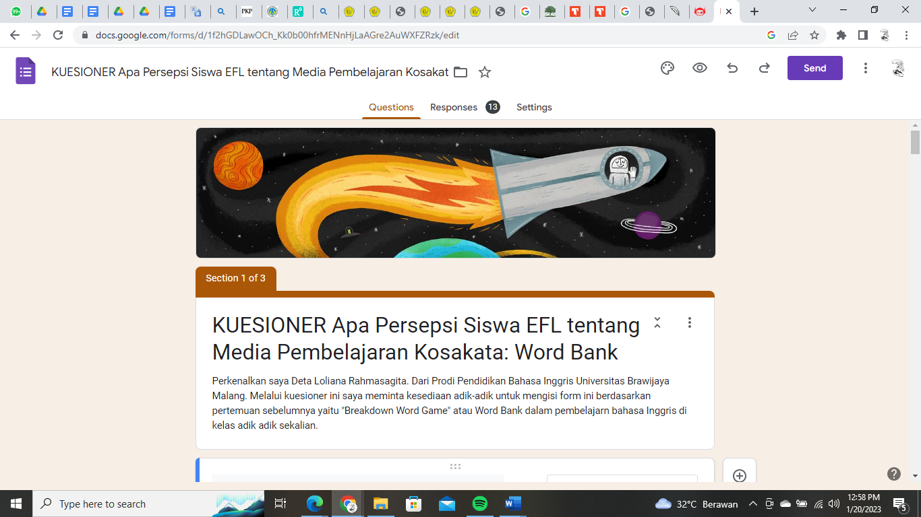

- Data retrieval


