EL-ECOSY: JURNAL EKONOMI DAN KEUANGAN ISLAM
Vol. …, No. … Januari 2019, hlm. …-…
Available at https://jurnal.unsur.ac.id/elecosy/index

PEMETAAN PENELITIAN SUKUK RITEL: STUDI BIBLIOMETRIK VOSVIEWER DAN LITERATURE REVIEW
Azhar Zahira Ramadhan¹, Indriana Irawati², Kin Kin Nilam Anjani³, Nadiyatul Falihah⁴
Fakultas Ekonomi, Universitas Islam Negeri Maulana Malik Ibrahim Malang
Corresponding Author e-mail: azharzahira15@gmail.com

ABSTRACT
This study aims to map the development of retail sukuk research from 2014 to 2024 using a bibliometric approach with VOSViewer software and literature review. Retail sukuk, as one of the Islamic financial instruments, plays a strategic role in enhancing economic development and financial inclusion. This research employs a mixed-method approach, combining quantitative bibliometric analysis of 102 scholarly articles from leading databases such as Scopus and Google Scholar, and qualitative literature review. The analysis reveals that retail sukuk research is concentrated on themes such as Islamic financial innovation, market stability, and green investment, with a growing focus on sustainability and liquidity management. Moreover, retail sukuk contributes to financing infrastructure projects, managing the national budget, and increasing small investors' participation. These findings are expected to provide strategic guidance for policymakers and Islamic finance practitioners, while opening opportunities for further research in Islamic finance and sustainability.
Keywords: retail sukuk, islamic finance, bibliometric mapping, financial inclusion.

INTRODUCTION
Sukuk is a sharia-based financial instrument that is increasingly popular among the public, especially in countries with large Muslim populations (Octisa et al., 2024). In recent years, the growth of sukuk has grown rapidly and has become one of the main financial instruments in various countries with large Muslim populations (Awaluddin, 2024). As an alternative instrument in the capital market, sukuk offers investment opportunities that are in line with sharia principles, which prohibit interest (riba), excessive uncertainty (gharar), and speculation (maysir) (Sunaryono et al., 2024). In contrast to bonds, conventional sukuk are based on the ownership of an underlying asset, where profits from the asset are shared with sukuk holders. Therefore, sukuk not only serve as an investment tool, but also as a means to encourage sustainable economic growth (Ma’ruf faried, 2021).
The issuance of sukuk has an important role in financing development. Based on the concepts and principles of Islamic finance, sukuk can function as an effective financing instrument in the development sector (Wijaya, 2021). In addition, sukuk can reduce the government's dependence on foreign debt, while optimizing the potential of domestic idle funds to finance government projects (Fad, 2021). By utilizing sukuk, economic development can be carried out more effectively and sustainably, which in turn creates prosperity for the wider community (Ajustina & Nisa, 2024). The positive response from the market to the publication of sukuk indicates that there is great interest, even to the point of oversubscription (Romadhoni et al., 2023). Therefore, strategic initiatives are needed to optimize opportunities in the development of this sukuk instrument.
The sukuk market has grown rapidly in the global sector, especially in Muslim-majority countries such as Malaysia, Brunei Darussalam, Saudi Arabia, United Arab Emirates, Bahrain, Qatar, and Indonesia (Nusran et al., 2021). Various entities, ranging from governments to private companies, have utilized sukuk to finance large infrastructure projects and diversify sources of funds (Ilmia, 2021). One type that has attracted attention is retail sukuk, which allows small investors to participate in Islamic financing by offering competitive returns compared to other financial instruments (Faningrum et al., 2024). Through the active role of retail sukuk, it is hoped that the community can be more involved in economic development while supporting sharia principles (Najib et al., 2023).
The purpose of this research is to map the development of
research on retail sukuk over a 10-year period from 2015 to 2024 using the VOSViewer bibliometric method and literature review. This mapping is important to understand the development of retail sukuk globally and regionally, identify existing research contributions, and uncover areas that require further study. Through this approach, it is hoped that the research results can provide new insights into the position of retail sukuk in the global financial landscape, as well as provide guidance for policy makers and financial practitioners in capitalizing on the potential.

RESEARCH METHODS
This research uses a mix-method approach, which combines quantitative methods in bibliometric analysis and qualitative methods in literature review. The focus of the research is Retail Sukuk, with the data used in the form of secondary data. The data includes research journal articles on Retail Sukuk obtained through searches on databases such as Scopus, Google Scholar, and Publish or Perish software. The data analysis process was conducted using Microsoft Excel, Mendeley Desktop, and VOSViewer software.
The main data came from the Scopus database, which was chosen for its rigorous peer review process and trusted reputation. The data was retrieved on November 20, 2024, involving 102 articles published between 2014 and 2024. These articles were obtained using the keywords Sukuk and Retail Sukuk, then exported in RIS format. To identify the most frequently occurring keywords, co-occurrence analysis was performed by setting a minimum threshold of keyword occurrence. A higher threshold results in a more accurate keyword analysis.
VOSViewer software version 1.6.20 was used for bibliometric analysis. VOSViewer functions to map and analyze various aspects, such as Co-authorship, Co-occurrence, Citation, Bibliographic Coupling, Co-itation, and main themes (Amalia & Suharso, 2024). The software also helps with data exploration, mapping, as well as clustering of analyzed articles. Keywords and countries are displayed in colored circles, with the size of the circle reflecting the frequency of occurrence in the title and abstract (Wibowo & Salim, 2022). The higher the weight of a topic, the larger the label and circle depicting it.

RESULTS AND DISCUSSION
Mapping the Distribution of Scientific Publications on Retail Sukuk 2014-2024
From the search results through the Google Scholar website, Scopus, and Publish or Perish Software in the range of 2014 - 2024, 102 scientific articles were obtained which included accredited national and international journals. The details of the search results are as follows:
Table 1. Scientific Publication Data on Retail Sukuk by Year

Year of Publication | Number of Publication Articles | Year of Publication | Number of Publication Articles | Year of Publication | Number of Publication Articles
2014 | 3 | 2018 | 10 | 2022 | 20
2015 | 3 | 2019 | 5 | 2023 | 12
2016 | 2 | 2020 | 13 | 2024 | 14
2017 | 5 | 2021 | 15
Total 102
Source: Data Processed, Microsoft Excel 2024.
Bibliometric Mapping of Research on Retail Sukuk 2014 - 2024
Based on the results of searching articles on the Google Scholar website, Scopus, and Publish or Perish Software which are exported in RIS (research Information Systems) format, then inputted and analyzed using VOSViewer Software, the following results were obtained:
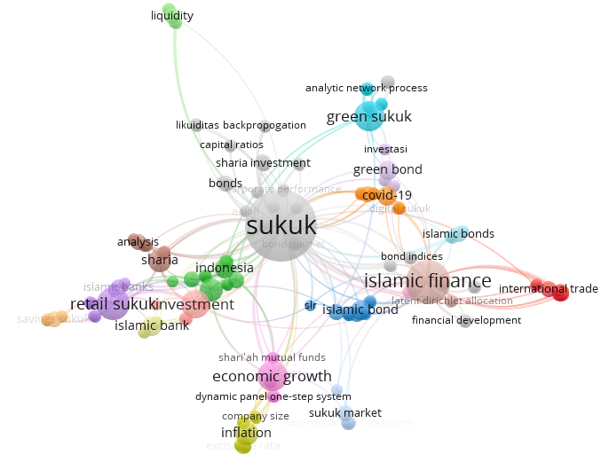
Source: Data processed, VOSViewer 1.6.20 software.
Figure 1. Network visualization of research development map around Retail Sukuk 2014 - 2024
From the search results on the Google Scholar site, 104 research articles were found that discussed sukuk and retail sukuk in Indonesia. The articles were then exported in RIS (Research Information Systems) format, processed, and analyzed using VOSviewer software, resulting in the following information.
The results of network visualization on the co-word map showing the development of research related to retail sukuk in Indonesia are divided into 5 clusters with a total of 87 items, as shown in Figure 1 below:
- Cluster 1. Red color, consists of 18 items, namely: agricultural economics, commodity futures, financial market, food commodity trading, food economics, food security, futures, globalization of wheat trading, globalization, international finance, international trade, Islamic financial innovation, options and swaps from the shariah perspective, pricing, shariah-based alternative, speculation on commodity markets, sukuk salam, wheat reserves.
- Cluster 2. Green color, consists of 13 items, namely: blue economy, blue sukuk, capital market, ijarah, Indonesia, inflation rate has on, Islamic mutual funds, Islamic stocks, Mudarabah, profitability, sharia supervisory board, sustainable development goals, yield.
- Cluster 3. Blue color, consists of 12 items, namely: bibliometric clustering, bibliometric visualization, descriptive analysis, Islamic bond, meta-analysis, qualitative research, Scopus database, slr, socially responsible investments, sri sukuk, synthesis analysis environmental finance, systematic literature review.
- Cluster 4. Yellow color, consists of 11 items, namely: bi rate, company size, economy growth, exchange rate, inflation, sharia mutual, sharia share, sharia stocks, sovereign sukuk, state retail sukuk performance, trade volume and sukuk yield.
- Cluster 5. Purple color, consists of 11 items, namely: bank internal, external, financial stability, internal factors, Islamic banks, macroeconomic indicators, retail sukuk, third parties funds, trade volume, trading volume of sukuk, vecm.
Overlay Visualization Mapping on VOSviewer
The overlay visualization mapping illustrates the publication timeline of research themes. The color of each overlay circle represents the average publication year of a particular theme. Darker colors indicate older publication years, while brighter colors indicate more recent publications.
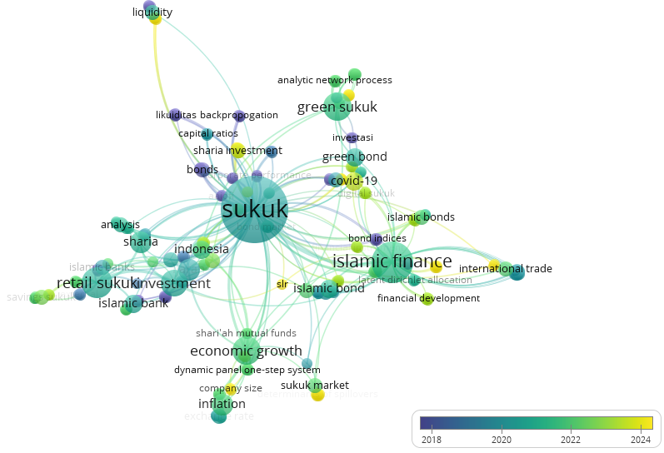
Source: Data processed, VOSViewer 1.6.20 software.
Figure 2. Visualization of Retail Sukuk Map Overlay 2014-2024
In the overlay visualization map shown in Figure 2, the darkest circles are dominated by themes such as bonds, conventional banks and investments. This indicates that the initial focus of the research was more on traditional financial instruments and their role in the context of sukuk. Subsequently, bluish-green topics such as Islamic Finance, economic growth, Retail Sukuk, and Green Sukuk began to emerge as interesting areas of study, particularly due to their relevance to economic growth and sustainability. More recent research, marked by bright yellow circles, includes themes such as Sukuk Market, Islamic Financial Innovation, and Sharia Investment. This highlights the focus on innovation in the Islamic finance sector, as well as the adaptation of the sukuk market to global challenges, including the impact of the COVID-19 pandemic and sustainability trends.
Mapping Density Visualization on VOSviewer
The density visualization mapping illustrates the level of discussion of a particular theme. Brighter objects indicate themes that have been widely discussed, while darker or more transparent objects indicate themes with less discussion. This mapping was conducted using the VOSviewer application to view various research objects in the field of Green Sukuk at the global level in the period 2015 to 2024.
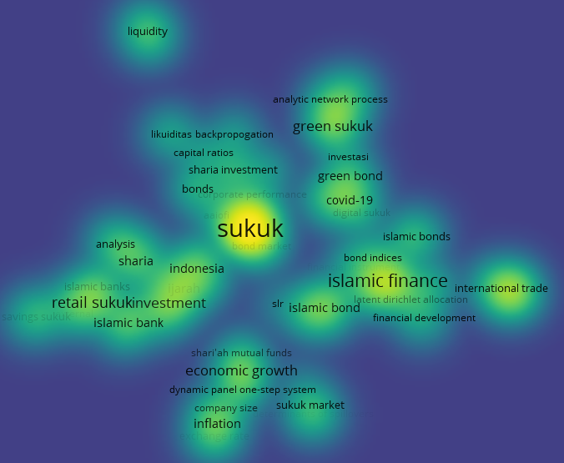
Source: Data processed, VOSViewer 1.6.20 software.
Figure 3. Visualization of Retail Sukuk Density 2014-2024
In the density visualization map shown in Figure 3, sukuk is a very frequently discussed theme, as seen from the intensity of the bright yellow color which shows the highest density compared to other themes. In addition, topics such as Islamic finance, Islamic bonds, green sukuk, sharia analysis and retail sukuk investment are also quite often a concern in research, marked by a more intense green color. Meanwhile, topics such as Islamic bonds, sharia investment, financial development and sukuk market show very low density, characterized by transparent colors that tend to be dark, which further confirms that these topics can be interesting opportunities for further exploration. This visualization provides important insights for identifying potential themes in sukuk-based research and Islamic finance.
Literature Review on Mapping Topics and Research Subjects on Retail Sukuk in Indonesia
From the results of analysis on the Google Scholar site, research related to retail sukuk in Indonesia is divided into five main themes, namely: Analysis of the Role of ROE in measuring the authenticity of sukuk, Sukuk market dynamics, The effect of retail sukuk on the performance of issuing companies, The role of retail sukuk in increasing development in Indonesia, the types of sukuk that are widely used in Indonesia.
Here are the details:
Analyze the role of ROE in measuring the success of sukuk
In the research journal Comparative Analysis of Profitability (ROE) of PT Bank Mandiri Syariah TBK Before and After the Issuance of Retail Sukuk for the 2017-2019 Period, information can be taken that by issuing Sharia Bonds (Sukuk), companies can meet their funding needs to increase the capital needed to support operational activities. The issuance of these bonds causes an increase in long-term debt and the company's capital structure. Bank Syariah Mandiri, as the first Islamic bank to issue Sharia Bonds (Sukuk), is expected to be an example for other Islamic banks.
Return on Equity (ROE) is a ratio used to measure the company's ability to generate profits for shareholders. The amount of ROE is also influenced by the level of company debt; the greater the proportion of debt, the ROE tends to increase. The ROE ratio is often referred to as return on equity. In some literature, this ratio can be linked to total asset turnover, which assesses how effectively a company utilizes its assets to generate return on equity.
The issuance of sukuk offers an alternative for companies to obtain funding from investors through the sale of part of the company's assets. With the more frequent issuance of sukuk, the capital obtained will also increase. Based on previous research, companies with higher ROE are considered more attractive to investors. This can increase investor interest in the securities issued, encourage demand in the secondary market, and potentially increase the bid price of the sukuk.
Thus, the issuance of Sharia Bonds (Sukuk) is one of the effective ways for companies to meet funding needs and improve capital structure. Bank Syariah Mandiri, as a pioneer of sukuk issuance in the Islamic banking sector, is expected to be a role model for other Islamic banks in utilizing sukuk as a strategic financial instrument.
Return on Equity (ROE) has an important role in assessing the company's ability to generate return on equity, which is also an indicator of attractiveness for investors. The higher the ROE value of a company, the greater the opportunity to attract investor interest in the securities issued, including sukuk. This can encourage an increase in demand and sukuk prices in the secondary market, which in turn has a positive impact on the company's performance and the financial market as a whole.
Sukuk Market Dynamics
Sukuk are financial instruments that are tradable, generate stable income, and are designed in accordance with Shariah principles. This instrument is a certificate of trust that aims to protect and promote welfare. Sukuk issuance has the main objective of creating financial balance in various sectors, including the balance sheets of governments, monetary authorities, companies, banks, financial institutions, and other entities that manage public funds.
The sukuk market in Indonesia is showing rapid growth based on recent data. In order to overcome the challenges in sukuk development, the Indonesian government and Islamic capital market players are expected to focus on three main components. First, a strong commitment is needed to develop solid investment projects through collaboration with strategic partners, effective coordination between stakeholders, and massive and thorough information dissemination.
The sukuk market is one of the important segments in the Islamic finance industry that has continued to show significant growth in recent decades. Sukuk, often referred to as Islamic bonds, are financial instruments that adhere to sharia principles, particularly avoiding elements of riba (interest), gharar (uncertainty), and maysir (speculation). Sukuk represent ownership of real assets or certain benefit rights, making them different from conventional bonds that only reflect debt. In the dynamics of the sukuk market, a number of factors influence its development, such as global macroeconomic conditions, regulatory policies, and increased awareness of ethical investment.
The global sukuk market is driven by high demand from investors who seek portfolio diversification while wanting to comply with Shariah principles. Muslimmajority countries such as Malaysia, Indonesia, and countries in the Middle East are the main markets for sukuk, with Malaysia leading as the main center of international sukuk issuance. On the other hand, non-Muslim countries such as the UK, Germany, and Hong Kong have also become active in the sukuk market to attract investments from Middle Eastern and Southeast Asian investors. This dynamic shows that sukuk is not only a financial instrument for the Muslim community, but also attractive to global investors due to its stability and asset-based appeal.
According to several studies, the government's agenda and policies in encouraging the development of sukuk are influenced by various factors, especially in the issuance of sukuk in Indonesia, Malaysia and Turkey. The most significant and consistent factor driving the increase in sukuk issuance in the three countries is the regulatory aspect, especially related to tax policy and the existence of a solid legal infrastructure to support sukuk practices.
A lighter taxation policy towards sukuk has proven to be able to significantly increase the issuance of this instrument. In addition, the second factor from the regulatory aspect that is crucial is the guarantee of legal security in its implementation, which is based on the positive law applicable in the country. In Indonesia, for example, legal certainty is an important element to ensure that sukuk do not have weaknesses when compared to conventional bonds. With clear and strong regulations, sukuk issuance can develop more optimally.
Challenges in the sukuk market include structural complexity and issuance costs that tend to be higher than conventional bonds as they require Shariah compliance. However, the market potential remains large, supported by initiatives by governments, international financial institutions and regulators that seek to simplify issuance procedures and increase market awareness. Examples are the standards issued by the Accounting and Auditing Organization for Islamic Financial Institutions (AAOIFI) and the International Islamic Financial Market (IIFM), which play a role in improving harmonization of practices across jurisdictions. In addition, the trend of green sukuk that fund sustainable and environmentally-friendly projects has become a new attraction, in line with the increasing global attention to Environmental, Social, and Governance (ESG) based investments.
The Effect of Retail Sukuk on Company/Bank Issuer Performance
Retail sukuk has a significant influence on companies, both in terms of funding and image. As one of the Islamic financial instruments, retail sukuk serves as a funding alternative that not only reduces dependence on interest-based loans, but also supports Islamic financial principles. The issuance of sukuk provides companies with access to capital at a relatively more stable and transparent cost than conventional bonds. In addition, the payment of returns based on profit sharing or margins in accordance with sharia principles provides flexibility in managing the company's cash flow.
The impact on company performance can be measured through indicators such as Return on Assets (ROA), which reflects the efficient use of funds obtained from sukuk. Studies show that sukuk issuance is able to improve operational efficiency and support long-term growth as funds are often used to finance productive projects such as infrastructure or business expansion. In addition, retail sukuk also enhances the company's reputation, especially among investors who are concerned about sharia principles, thus expanding the investor base and supporting the development of Islamic financial markets in general.
The issuance of retail sukuk has a significant effect on company performance, especially in terms of market reaction reflected through changes in stock prices. When a company issues sukuk, it gives a positive signal to investors regarding the financial health of the company, which can increase investment interest and, in turn, increase the value of shares in the market. In addition, sukuk issuance also contributes to an increase in the company's operating capital, which can boost productivity and overall economic growth.
The Role of Retail Sukuk in Enhancing Development in Indonesia
Based on the literature, there are research subjects that allude to the role of sukuk in improving development in Indonesia. Most of the research explains that the role of retail sukuk which greatly influences development in Indonesia is through APBN financing. Then there are other studies that discuss many other roles.
Sukuk is a source of state budget financing. It is known that currently Outstanding state sukuk is worth 18 percent of the total outstanding state securities (SBN). In the context of financing the state budget, state sukuk has been issued at 27- 30 percent of the total SBN. State budget financing through Sukuk provides very productive support for the state budget. Project-Base Sukuk (PBS) is the largest form of sukuk issued, the issuance of this state sukuk is based on government infrastructure projects.
State sukuk is a very important instrument for financial inclusion. Retail State Sukuk (Sukri) and Savings Sukuk (ST) have become important Islamic investment tools for Indonesians. With a total supply of around IDR 147 trillion and more than 255,000 investors, retail Sukuk has successfully encouraged the transformation of society from a savings culture to an investment culture. Competitive returns and government transparency create trust and incentives for people to invest in the capital market. Through this instrument, people not only gain financial benefits but also gain a better understanding of capital market-based investments.
Sukuk is an instrument that encourages the development of the Islamic financial industry in Indonesia, both Islamic banks, Islamic banking institutions and Islamic capital markets. State Sukuk plays a strategic role as an investment instrument and liquidity management in supporting the growth of the Islamic finance industry. In addition, State Sukuk is an important reference for corporations in issuing corporate sukuk, encouraging synergy between instruments and the Islamic financial sector. Based on OJK data as of August 31, 2018, total Islamic banking assets reached Rp445.24 trillion (5.72ri of total national banking assets), while Islamic IKNB assets reached Rp99.96 trillion (4.36ri of total national IKNB assets). In addition, the managed funds of Islamic mutual funds amounted to Rp31.13 trillion (6.31ri of total national mutual funds), showing the significant contribution of the Islamic sector in the development of the national financial industry.
Sukuk also plays a role in supporting financial market stability, this is because the majority (around 95%) of government sukuk denominated in Rupiah are owned by domestic investors, including institutions and individuals. The characteristics of Islamic investors who tend to be cautious and do not contribute speculatively to the stability of the state sukuk market. This is reflected in the lower volatility of government sukuk yields compared to traditional bonds, making it a stable product.
Sovereign sukuk play a key catalytic role in the development of Islamic finance at the global level. Through innovative and sustainable issuance, state sukuk not only represent an attractive investment vehicle, but also strengthen the position of Islamic finance as an integral part of the international financial system. With its globally referenced structure and themes, Sukuk Negara has successfully set a trend that will drive the growth of the Islamic finance industry.
The regular issuance of US dollar-denominated Global Sukuk confirms its important role as an investment and liquidity management instrument in the global Islamic finance industry. Indonesia managed to record outstanding corporate sukuk of IDR17.34 trillion (4.15 percent of total outstanding corporate bonds) and sharia stocks from 395 issuers reached IDR3,555 trillion (52.41 percent of total stock market capitalization). This success was supported by instrument innovation that became a global trendsetter, both in sharia structure and theme, which further strengthened the attractiveness of State Sukuk in the international market.
Types of Sukuk that are widely used in Indonesia
There are 6 studies with subjects about the types or types of sukuk used in Indonesia that have diverse views and there are several classifications, namely:
There are 4 studies describing Sukuk which are classified based on the contract underlying their issuance, including: first, Sukuk Mudarabah, which is a sukuk issued using a Mudarabah contract with a mechanism where there are rab al maal and mudharib parties, the profits of both parties will be shared according to the agreement, but if there is a loss, it will be borne by the capital provider only. Second, Sukuk Musyarakah is a sukuk issued using a musyarakah contract, profits and losses on this sukuk will be borne together according to the agreement. Third, Sukuk Murabaha is a sukuk issued with a Murabaha contract, this sukuk has a sale and purchase contract system. Fourth, Sukuk Salam is a sukuk with an upfront payment contract, and the goods are sent later. Fifth, Istisna' Sukuk is a sukuk issued using an istisna' contract, then the related parties agree on the sale and purchase of financing for assets or projects at a price, time, and specifications determined at the beginning. Fifth, Sukuk Ijarah is a sukuk issued based on an ijarah contract where there are parties selling or leasing an asset with an agreed period. Sixth, Sukuk wakalah. Fifth, Sukuk salam. Seventh, Sukuk combined portfolio, and eighth, state sharia securities (SBSN).
There is 1 research explaining that according to AAOIFI (Accounting and Auditing Organization of Islamic Financial Institution) tribes are divided into two types including sukuk that can be traded and sukuk that cannot be traded. Tradable sukuk are sukuk mudharabah, ukuk musyarakah, and sukuk ijarah. While sukuk that cannot be traded are sukuk istisna' and sukuk salam. Then in the practice of the stock exchange, it states that based on the issuance of sukuk, it consists of State Sukuk (sukuk issued by the government) and Corporate Sukuk (sukuk issued by both private and stateowned companies.
Then 1 research describes about state sukuk and corporate sukuk. State sukuk or state sharia securities (SBSN) are securities issued by the government of the Republic of Indonesia through the ministry of finance based on sharia. Types of state sukuk include retail sukuk, savings sukuk and waqf sukuk. Retail Sukuk is a sukuk issued by retail investors with a minimum of 1 million with a period of 3 years and provides a fixed yield, this sukuk can be traded in the secondary market. Savings sukuk is a sukuk intended for retail investors of at least 1 million with a period of 2 years, but this sukuk cannot be traded in the secondary market. Finally, waqf sukuk, waqf sukuk or Cash Waqf Linked Sukuk (CWLS) is a type of investment coupled with waqf, so the profits from the investment will be endowed channeled through waqf institutions. Starting with a nominal value of 1 million with a period of 1 to 2 years. This sukuk cannot be traded. Meanwhile, corporate sukuk according to OJK is a fixed-income instrument issued based on sharia. The income obtained in this sukuk is based on the contract stated in the OJK regulations such as the istisna 'contract and the musyarakah contract.

CONCLUSIONS
- Bibliometric mapping of retail sukuk research over the period 2014-2024 shows significant developments, especially on themes such as Islamic financial innovation, sukuk markets, and Shariah-based investments. The findings provide insight that the focus of research is gradually shifting from traditional financial instruments to more innovative and sustainable areas.
- Bibliometric analysis identifies that retail sukuk is a strategic financial instrument in supporting economic development in Indonesia, both through financing infrastructure projects and increasing financial inclusion. The role of retail sukuk in encouraging public investment is increasingly relevant to the success of government programs in managing the state budget productively.
- The methods applied, such as the use of VOSViewer software, were effective in mapping research trends and identifying key research clusters, which include Islamic finance, green economy, and market stability themes. This suggests that a bibliometric approach can be a strategic tool to understand the research landscape and its contribution to Islamic finance policy.
- From the literature review, it was found that retail sukuk not only offer financial benefits, but also contribute significantly to the development of the Islamic finance industry and national economic stability. These findings reinforce the importance of innovation in sukuk structure and issuance to support global competitiveness.
This conclusion also opens up prospects for further research on the social and environmental impact aspects of retail sukuk issuance, especially in supporting the sustainability agenda and ESG-based investments.

REFERENCES
Ajustina, F., & Nisa, F. L. (2024). Implementasi Prinsip Ekonomi Syariah Terhadap Pengembangan Ekonomi Umat Untuk Meningkatkan Pertumbuhan Ekonomi. Jurnal Ilmiah Ekonomi Dan Manajemen, 2(6), 626–637.
Amalia, E. F., & Suharso, P. (2024). Pemetaan Artikel Jurnal Go Green di Universitas Diponegoro: Analisis Bibliometrik dengan Visualisasi VOSviewer. Jurnal Pustaka Ilmiah, 10(1), 54. https://doi.org/10.20961/jpi.v10i1.78336
Awaluddin, M. (2024). Teori Portofolio dan Analisis Investasi Syariah. Yayasan Tri Edukasi Ilmiah.
Fad, M. F. (2021). Waqf Linked Sukuk dalam Perspektif Maqashid Syari’ah. Journal of Islamic Studies and Humanities, 6(1), 44–62.
Faningrum, E., Sularno, M., & Rochman, F. (2024). Analisis Minat Masyarakat Terhadap Pembelian Sukuk Ritel Syariah Sebelum dan Saat Pandemi. Jurnal Al-Istishna, 1(1), 14–29.
Ilmia, A. (2021). Sukuk Negara Dan Pembangunan Infrastruktur Di Indonesia. Finansha: Journal of Sharia Financial Management, 1(2), 22–34. https://doi.org/10.15575/fsfm.v1i2.10761
Ma’ruf faried. (2021). Review Peluang dan Tantangan Sukuk di Masa Pandemi Covid-19 Sebagai Instrumen Keuangan Syariah Indonesia. Al-Tasyree: Jurnal Bisnis, Keuangan Dan Ekonomi Syariah, 1(1), 1–8.
Najib, M. T. A., Sa’adah, S. R., & Putro, R. L. (2023). Penentu Perkembangan Pasar Sukuk: Makroekonomi Dan Institutional Quality. Jurnal Manajemen, Akuntansi, Ekonomi, 2(1), 1–11. https://doi.org/10.59066/jmae.v2i1.238
Nusran, M., Parakassi, I., Siri, R., Akil, M. A., Misbahuddin, M., Yasen, S., Arifai, S., Awaluddin, M., Ab, A., & Razak, M. (2021). Transformasi Lembaga Keuangan Dalam Mendukung Sektor Usaha Untuk Pengembangan Industri Halal.
Octisa, M., Ainulyaqin, M. H., Achmad, L. I., & Edy, S. (2024). Peningkatan Minat Masyarakat Dalam Berinvestasi Sukuk di Indonesia : Suatu Tinjauan Fenomenologi. Jurnal Ilmiah Ekonomi Islam, 10(02), 1316–1325.
Romadhoni, D. D., Ramidah, N., & Damayanti, R. K. (2023). Optimalisasi Peran Sukuk sebagai Instrumen Investasi Syariah dalam Mendorong Pembangunan Ekonomi Nasional. Diponegoro Journal of Islamic Economics and Business, 2(2), 85–98.
Sunaryono, S., Sepriano, S., & Uzma, I. (2024). Investasi Syariah Terpadu: Strategi dan Peluang Saham Tanpa Riba. PT. Sonpedia Publishing Indonesia.
Wibowo, E., & Salim, T. A. (2022). Analisis Bibliometrik Penelitian dengan Tema “Digital Archive.” Jurnal Ilmu Informasi, Perpustakaan, Dan Kearsipan, 24(2), 93–105. https://doi.org/10.7454/jipk.v24i2.004
Wijaya, R. H. (2021). Investasi Syariah Dan Pertumbuhan Ekonomi: Optimasi Peran Sukuk Sebagai Penunjang Pembangunan Ekonomi Nasional. Jurnal Ekonomi Syariah, 6(1), 70–82.

